Ching Hey Lau

chinghey.lau@newhallstudent.co.uk/ hheylau@gmail.com

Investigating project

Computer science NEA 2022-2023

Unity 3D Maze Runner Game

Content Page

1. Analysis 5

1.1 Introduction 5

1.1.1 Background 5

1.1.2 Project Scope 5

1.1.4 Target audience 6

1.2 Investigating Project 6

1.2.1.2 Questionnaire and Statistics 6

1.2.1.4 Existing Software 12

1.2.1.5 Prototyping 18

1.2.10 Analysis Data Dictionary 19

1.2.11 Data File Size /Volume 19

1.3 Specific Objective 19

1.3.1 Splash Screen 19

1.3.2 Main Menu 19

1.3.3 Setting Screen 20

1.3.4 Quit Panel 20

1.3.5 LeaderBoard 20

1.3.6 Login & Register 20

1.3.7 Start Game Save Slot Selection Panel 21

1.3.8 First Time 21

1.3.9 Character Selection 21

1.3.10 Maze Generation 21

1.3.11 Loading Screen 21

1.3.12 Main Game 21

1.3.13 Weapon 21

1.3.14 Monster 22

1.3.15 Maze 22

1.3.16 Exit 22

1.3.17 Health 22

1.3.18 Pause Menu 22

1.3.19 Game Over 22

1.4 Additional Objectives 23

1.4.1 Path Finding 23

1.4.2 Visual Improvement 23

1.4.3 Monster 23

1.4.4 Special Feature 23

1.4.5 Quest System 23

1.4.6 Achievement System 23

1.4.7 Inventory 23

1.4.8 Pick Up 23

1.4.9 Music 23

1.4.10 Rewards 23

1.4.11 Online Service 23

1.4.12 Multiplayer 23

1.4.13 Ghost System 24

1.4.14 Wooden box 24

1.4.15 Vending Machine 24

1.4.16 Terrain 24

1.4.17 Action Replay 24

1.4.18 Player Profile 24

1.4.19 Database 24

1.5 Proposed solution 24

2. Design 25

2.1 High-level overview 25

2.1a System flowchart (whole diagram) 25

i) Login Screen and splash screen 26

ii) Main menu screen (Leaderboard, Setting, Quit and Start Game) 27

iii) Maze Game 28

iv) Game Over Screen 29

2.1b Data Flow Diagram 29

2.2 Modular in structure of system 30

2.2a Site map 30

2.2b System chart 31

2.2c Table of Class 31

2.2d Variable declaration of Main Algorithm 42

2.2e IPSO 45

2.3 Data Items & structures 46

2.4 Data Structures 46

2.5 File Structure and Organisation 47

2.6 Identification of main algorithms 47

2.6a Health Bar 47

2.6b Maze Generation (DFS) 48

2.6c Stack 49

2.6d Merge Sort 50

2.6e Binary Search 50

2.6f Opening Sequence (Fisher-Yates shuffle) 51

2.6g Gravity 51

2.6i Dijkstra 51

2.6j Hashing 55

2.6k Circular Queue 55

2.6l Time 55

2.6m hexadecimal → denary 56

2.6n Register checking 56

2.6o Fading 57

2.6p Outermost Wall and Exit Tunnel 57

2.6q Linked List 58

2.6.1 Online Query 60

2.6.2 local SQLite Query in Save0/1/2.sqlite3 62

2.7 Class diagram (UML) 65

2.8 Identification of Storage Media 67

2.9 HCI Rationale 67

2.10 HCI Sample of Planned Input Design 67

2.11 HCI planed output design 71

2.12 Hardware and Software requirement 71

2.13 Description of measures planned for security and integrity of data 71

2.13a Security of the data 71

2.13b Integrity of the data 71

2.13c Access Control 71

2.14 System security 71

2.15 Overall Test Strategy 71

3. Technical Solution 72

4. Testing 72

4.1 Testing method 72

4.2 Test Evidence 73

4.4 User Acceptance testing 79

5. Feedback and Evaluation 80

5.1 Overall effectiveness 80

1.3.1 Splash Screen 80

1.3.2 Main Menu 80

1.3.3 Setting Screen 80

1.3.4 Quit Panel 81

1.3.5 LeaderBoard 81

1.3.6 Login & Register 81

1.3.7 Start Game Save Slot Selection Panel 81

1.3.8 First Time 82

1.3.9 Character Selection 82

1.3.10 Maze Generation 82

1.3.11 Loading Screen 82

1.3.12 Main Game 82

1.3.13 Weapon 82

1.3.14 Monster 83

1.3.15 Maze 83

1.3.16 Exit 83

1.3.17 Health 83

1.3.18 Pause Menu 83

1.3.19 Game Over 84

5.1 User Feedback 84

5.1.1 Positive comment I have got is: 84

5.1.2 The negative comment: 84

5.3 Improvement and extension 84

5.3.1 The improvement comments that player has given is: 84

# 1. Analysis

## 1.1 Introduction

### 1.1.1 Background

Maze Runner has been a best-selling thriller movie since its release in 2014 and is based on the novel by [Noah Oppenheim](https://www.bing.com/ck/a?!&&p=1f6dfeea94717e41JmltdHM9MTY3OTM1NjgwMCZpZ3VpZD0zMWU5YmYwOC02OTMxLTZlNWItMzNhZC1hZGIzNjgzOTZmM2EmaW5zaWQ9NjIwOA&ptn=3&hsh=3&fclid=31e9bf08-6931-6e5b-33ad-adb368396f3a&u=a1L3NlYXJjaD9GT1JNPVNOQVBTVCZxPU5vYWgrT3BwZW5oZWltJmZpbHRlcnM9c2lkOiJjNDkyYTNhNi1jN2Y2LTZkYjAtZDgzMy05ZWExNzQ1ZGI5ODgi&ntb=1). In the story, a group of boys who are immune to a zombie virus are trapped inside a mysterious maze for scientific investigation. Scientists have found that higher brain activity creates more immune substances, so they put in a giant and poisonous monster called Griever. They are trapped inside a moving maze with a different opening sequence every day. The story is about the main character, Thomas, who has been trying to uncover the secret of the maze and leading a team to get out of the maze.

This film is one of my favourite movies as the audience is immersed as Thomas, through him, we understand how the maze works and the relationship and mentality of the aborigines. The scene of Thomas bravely exploring and surviving inside the maze successfully makes the audience feel intensely worried about him. After the movie, I had been dreaming of myself as Thomas, dealing with the "horrible monster" and exploring and escaping the maze. Also, as a survival movie, humanity, betrayal, and trustworthiness have been emphasized, which has which makes you reflect on what it means to be a human in society.

There are lots of maze-solving games, but only a few of them are similar to the movie. I would like to make a game on top of the original storyline that would simulate Thomas, the main character, contributing to the village and communicating with and building relationships with NPCs. And once Thomas has gained enough resources, he can solve the maze, escape, and handle the zombie outside of the maze. Also, I would like to make this game as realistic as possible, as the settings and story of the game could happen, and the player needs to immerse himself in the world of The Maze Runner.

### 1.1.2 Project Scope

The genre of my game will be Role Play Game and maze solving game. As an RPG game, the player will substitute into the main character to grow and explore the maze and villages. The resource will be randomly generated in the zone like woods in the forest zone. Food can be found in the farming zone which randomly generated every 2 days. Houses with a craft table which used for building tools and trap will be in the village zone.

As an RPG game, the interaction of NPC and the plot is important to the game. Tutorial will be shown in dialog from the NPC to let the player fully understand the game mechanics. Player needs to collect resource in the zone mentioned above to craft the weapon to attack and defence the grievers. The player should allow to explore the maze when he has the basic kit of exploring. As the player collect more rare resources, they could upgrade the weapon or create different utilities such as traps.

There is similar type of maze game called labyrinth game. However, labyrinth game doesn’t aim to be explore or solve. It provides a fixed path without a dead-end. In compare to maze-game which is opposite to labyrinth leads to higher difficulties. To make the game unique, the maze is randomly generated in every new game so the player won’t get bored or reciting the maze pattern and gate opening sequence.

There are 8 separate maze zone in each game and every zone include a path to reach to the outer maze between the wall pattern. The gate of the maze only opens in daytime and close at sunset. Player needs to navigate the maze to the outer maze using the help of mini-map and hints on the wall to pass through the maze. Player has to fight with the monster alone if he didn’t get back to the safe zone. The monsters will start attacking the player every few second if the monster is close to the player until the player or monster is dead or far away. Once the monster dead, rare loots or key will have a chance for player to pick up. However, if the player is dead, he would have an option to rewind to few minutes ago or respawn in the safe zone.

Monster will only spawn in night-time in the maze area. They will move slowly to the player using A* path finding algorithm and chase the player once monster has alerted and detected the player. There will be abundant of monsters but most of them are weak. Blades and a main boss griever will be spawn in the outermost maze before player can exit through the escape tunnel. Once the boss monster is dead, all monster will be destroyed and no more monster will be spawned. To escape the maze, password and enter key must be found in the maze before the maze gate can be opened.

Some of the character in my game will be based on the movie. I will add different ability to each character including speed boost and strength increase to differentiate different type of player by choosing the player’s best fit. For the texture of this game, it could have more variant such as Japanese traditional temple maze or the Beijing palace. The UI design could be using command line interface to fit into the plot of Maze Runner which everything in the maze is generated by a supercomputer.

### 1.1.4 Target audience

Based on the results collected from the Questionnaire on the 1.2.1.2, the game will target on male gamers around the age of 15 to 25 most of whom are students. The majority of the respondents do play games however their time is quite limited and they mainly play at the weekend or 1-2 days per week. Also, mobile platforms and Nintendo switch are popular platform teenagers play on and because of the easy to access in terms of hardware and time. Two main factors have influenced my decision making process for this project. Firstly, the fact that most teenagers now own a mobile phone, which are generally cheaper than a pc. Secondly, the limited time available to teenagers to play. These points have convinced me to build the game on mobile platforms. As this game is designed to be realistic, with blood effects and will include challenging puzzles, this game will not be available to children.

## 1.2 Investigating Project

### 1.2.1.2 Questionnaire and Statistics

===================Personal Detail/ client ======================

1. Gender

Male ----(5 votes) (71.43%)

Female----(2 votes) (28.57%)

1. Age Range

Under 12 ----(0 votes)

12-15 ----(0 votes)

15-17----(2 votes) (28.57%)

18-25 ----(5 votes) (71.43%)

26-35----(0 votes)

Over 35----(0 votes)

1. What is your job currently

Part-time job ----(1 votes)

Student ----(6 votes)

1. How often do you game?

I don’t play games ----(0 votes)

Weekend ----(5 votes) (71.43%)

3-5 days per week ----(0 votes)

Every day ----(2 votes) (28.57%)

Most of the respondents play on the weekend. This game should not force players to login every day to gain special items

1. How long do you game?

0-1 hr/day ----(4 votes) (57.1%)

1-2hrs/day ----(1 votes) (14.3%)

2-3hrs/day----(2 votes) (28.57%)

more than 3 hours /day ----(0 vote)

Most of the respondents play less than 1 hour, so I will adjust the game to be fun and intense as well as taking less time to complete.

1. How often do you open a game more than once a day

Always ----(4 votes) (57.1%)

Seldom ----(3 votes) (42.9%)

Never ----(0 votes)

the game should consider having a pause and continue function so that the player can continue their last session.

1. What game platform do you prefer

Mobile ----(3 votes) (42.9%)

PC ----(5 votes) (71.4%)

XBOX or PS4 ----(2 votes) (28.6%)

Nintendo switch ----(3 votes) (42.9%)

Although PCs have the most votes, mobile platforms including mobile and Nintendo switch combined have gained a larger portion than PC player

1. What kind of game do you prefer

Role-playing Game ----(4 votes) (57.1%)

First Person Shooter ----(5 votes) (71.43%)

Third Person Shooter ----(1 votes) (14.3%)

Battle Royale ----(2 votes) (28.6%)

Arcade game ----(2 votes) (28.6%)

Sandbox (Minecraft/ Terraria) ----(5 votes) (71.43%)

Puzzle / Problem solving game----(3 votes) (42.9%)

Action-Adventure game ----(4 votes) (57.1%)

Most People like sandbox, First Person Shooter. This proves most respondents are familiar with playing 3D games and know most of the 3D game mechanics. Role-playing games and action adventure games come as second which shows the rewards and game experience is important to the player.

=========================Gameplay ========================

1. how long should one game session last?

5 -10 mins ----(1 votes) (14.3%)

10-15 mins ----(4 votes) (57.1%)

15--20 mins ----(2 votes) (28.57%)

most of the people don’t want a game to last too little time or too long. 10 -15minutes is the best time range for most of the respondents

1. In a game fighting with AI monster, what weapon would you prefer?

melee ----(1 votes) (14.3%)

Explosive----(2 votes) (28.57%)

knife ----(1 votes) (14.3%)

punch ----(0 votes)

arrow or throwable weapon-----(5 votes)(71.4%)

most of the players would like to deal some damage to the monster without getting too close to the monster. Throwable weapons will be added as a weapon option

1. What fight mode do you prefer?

defensive(trap) ----(1 votes) (14.3%)

attacking (arrow, stone, sword and maybe gun) ----(6votes) (85.7%)

most of the players would like to active attack the monster instead of defensive playing. It is because defensive is more unpredictable compared to attacking. And you gain rewards from killing monsters by player himself.

1. Which one do you prefer the frequency of monster appearing?

Weak but abundant ----(1 votes) (14.3%)

Strong but few ----(6 votes) (85.7%)

Most of the respondents prefer few monsters but will high damage or enhanced health.

1. In a game, which mode do you prefer

Endless mode ----(0 votes)

With an ending (then restart) ----(7 votes) (100%)

Most of the players want to have a game with an ending. An ending could be an emblem of the player beating the game

1. After the game end, how should the game behave?

go to next level ----(5 votes) (71.4%)

stay at current game session----(2 votes) (28.57%)

Most players want to challenge for a harder level instead of improving the current score and level before moving on. The player may have limited time so the next level will automatically loaded after the player beats the game.

1. Which attack mode do you prefer

Aim to attack ----(5 votes) (71.43%)

Distance to attack ----(2 votes) (28.57%)

most of the respondents would like to attack the monster precisely by aiming with crosshair and make the game more realistic.

1. Should NPC (AI) affect the overall gameplay? Different objective

Yes ----(6votes) (85.7%)

No ----(1 votes) (14.3%)

The NPC could prove different objective and reward after objective have met. Also, the key to opening the gate could also be gained by killing the monster.

1. should game add a loot box(chest) or bonus box

Yes----(7votes) (100%)

No ----(0 votes)

A loot box should be automatically spawn at the start of the game and loot box will spawn inside the safe zone

1. Which one do you prefer

Time limited ----(2 votes) (28.57%)

No time limit ----(5 votes) (71.43%)

Most of the respondents don’t want to have a limit on time. It may because it is have too much pressure on playing a game.

1. Which way is the best way for a player to gain money

collect resource gems ----(0 votes)

loot from the monster ----(1 votes) (14.3%)

complete the quest ----(5 votes) (71.43%)

Selling stuff and earn token----(0 votes)

By working, wood-cutting, farming ----(1 votes) (14.3%)

Most respondents has chosen completing the quest to gain money. It could combine with the objective provided by the NPC.

1. Should level system link to difficulty

Yes----(6votes) (85.7%)

No ----(1 votes) (14.3%)

most of the respondents would like to merge difficulty with level which means higher level will be more difficult.

1. should the game include weekly login/daily login bonus?

Yes ----(4 votes) (57.1%)

No ----(3 votes) (42.9%)

The game should award player who play this game every period of time by giveaway rare weapon and coins

1. Do fast travel/ player teleport affect game balance

Yes ----(5 votes) (71.43%)

No ----(2 votes) (28.57%)

Fast travel will affect the game balance according to most of the respondents so this feature will not be added into the game. Reasons may be unfair to the time used to other player.

1. when the final boss is killed, should side/minor monster be

Stay in the game for player to kill ----(3 votes) (42.9%)

Die with the boss ----(4 votes) (57.1%)

Tame-able/loyal to player ----(0 votes)

All monster should be dead when the boss (main monster) is dead.

1. When should the monster awake and chase the player?

Only daytime ----(0 vote)

Only night-time ----(2 votes) (28.57%)

Both----(5 votes) (71.43%)

as the monster can trigger loot and reward, most of the respondence are willing to fight with the monster no matter when the time of the day is.

1. Should day and night last?

fast ----(4 votes) (57.1%)

slow ----(3 votes) (42.9%)

most of the respondents prefer faster paced game and it could save the time and make the game become more intense.

1. What player should award by finish objective?

Token/ coin ----(1 votes) (14.3%)

Level up ----(1 votes) (14.3%)

Rare weapon ----(4 votes) (57.1%)

Power and effect (strength and invisible) ----(1 votes) (14.3%)

Most respondents chose rare weapon as a reward after finishing the objective of the game.

1. What powerup do you like to appear most often

Strength -more attack ----(4 votes) (57.1%)

stealth, invisible----(4 votes) (57.1%)

Run 1.2x faster ----(4 votes) (57.1%)

Get the path of the maze ----(1 votes) (14.3%)

There is a tie with strength, stealth and speed boost power-up. Those 3 of the powerup would be randomly chosen by the system.

1. For easy level

decrease monster hp (health) ----(5 votes) (71.43%)

increase damage of weapon ----(1 votes) (14.3%)

higher chance to get expensive item ----(2 votes) (28.57%)

The monster health should be decreased to match the difficulty of easy level.

1. How should level be measured?

By monster kill count ----(1 votes) (14.3%)

By money earned ----(1 votes) (14.3%)

By number of objectives finished ----(3 votes) (42.9%)

by timer ----(2 votes) (28.57%)

Most respondents agree to have the more objective finished, the higher level you could earned.

1. Earn money by

timer ----(0 votes)

killing count ----(7votes) (100%)

Most respondents would like to gain money by player killing monster.

1. which one do you prefer

multi tab setting menu----(5 votes) (71.43%)

scrollable setting menu ----(2 votes) (28.57%)

Multi-tab setting menu would be used in the setting menu of my game.

1. should monster start attack you in sight.

Yes ----(6votes) (85.7%)

No ----(1 votes) (14.3%)

The monster will attack player only when monster have seen player.

1. would you rather have a default weapon or random weapon provided?

Default weapon (strong) ----(3 votes) (42.9%)

random weapon (sniper, shotgun, AK 47) ----(4 votes) (57.1%)

Most respondents would like to have different choice and properties of weapon.

1. In the game, which chasing method of monster you prefer?

moving to you slowly constantly ----(5 votes) (71.43%)

moving fast but stop in a while ----(2 votes) (28.57%)

The speed of the monster should be slower than the walking speed of the player to give enough space for player to attack and escape.

1. Which kind of currency do you prefer

counting in dollars ----(6votes) (85.7%)

counting in 100 ----(1 votes) (14.3%)

Most respondents prefer an actual amount of imaginary large number of money in game

1. where do you want to path appear?

On the mini-map ----(6votes) (85.7%)

visible on the floor ----(1 votes) (14.3%)

There should be a path visible in the mini map inside the game

1. Should weather affect the movement?

(Rainy day walk slow, sunny day speed boost)

Yes----(4 votes) (57.1%)

No ----(3 votes) (42.9%)

The weather system should be added into the game which special effect due to the weather.

1. If player die, should the player.

Be punish in some way (health bar decrease or some coin lost) ----(4 votes) (57.1%)

act like nothing but death count + 1 ----(3 votes) (42.9%)

Over half of the respondents would like to have a punishment when the player is dead

1. If the player respawn, should player spawn in

the safe zone (far from exit) ----(7 votes) (100%)

where player dead (maybe unsafe or near to another trap) ----(0 vote)

Most respondents would like to respawn into the safe zone no matter they have to reexplore the map again.

1. Which aim do you prefer?

Kill 20 monster ----(4 votes) (57.1%)

Explore 3 zone ----(4 votes) (57.1%)

Survive a cruse night attack ----(4 votes) (57.1%)

collect 30 coins ----(1 votes) (14.3%)

Find a secret tunnel ----(4 votes) (57.1%)

Objective that respondents would like to have is killing certain amount of monster or a wave of monster, exploring the map and the secret tunnel.

1. Which perspective you would like a 3D Maze Runner to be?

First Person ----(1 votes) (14.3%)

Third Person ----(1 votes) (14.3%)

Both (switchable) ----(5 votes) (71.43%)

Most respondents would like to have a choice changing between first and 3rd person perspectives

1. Do you like lobby music (background music)

Yes ----(5 votes) (71.43%)

No----(1 votes) (14.3%)

Sometimes ----(1 votes) (14.3%)

Most of the respondents would like to have music playing in the background while in main menu and game lobby

1. Should the speed/ strength of different character be different?

Should be different ----(6 votes) (85.7%)

Should be the same ----(1 votes) (14.3%)

Most respondents would like to see more variant available in the game including characters and their own different abilities.

1. What is the best way to heal/ recover health?

Buy food from the shop (spend money) ----(6 votes) (38%)

Free limited supply of medicine each round----(4 votes) (24%)

Collect heart from the ground----(2 votes) (13%)

Kill monster and have a chance to heal----(4 votes) (24%)

Most respondents prefer spending money to buy medicine to recover the health.

1. Which power-up would you prefer

speed increase ----(5 votes) (71.43%)

destroy monster near player (in range) ----(2 votes) (28.6%)

Slowness ----(1 votes) (14.3%)

Strength ----(6votes) (85.7%)

Instant health increase ----(5 votes) (71.43%)

Resistance to attack ----(4 votes) (57.1%)

Invisible/ Invincible to monster ----(4 votes) (57.1%)

Most of the respondents prefer having strength power-up which deals more damage to the monster.

=================Comment on my game ============================

1. Have your ever watch maze runner （移動迷宮）？

Yes ----(4 votes) (57.1%)

No ----(3 votes) (42.9%)

the next 2 question will be based on the answer from question 46.

Most of the respondents have watched maze runner.

1. Do you like that film?

Yes ----(4 votes) (57.1%)

No ----(3 votes) (42.9%)

All of the 4 respondents who watched the movie like the film. This proves the high selling box office of the maze runner has gained exposure and reputation could made this game become popular and easy understand plot.

1. What feature of the movie would you prefer to add into the game?

(The monster? the WCKD laboratory? the farming in safe zone?)

-WCKD laboratory

-The farming area in safe zone

-Storyline from the movie

The zone could contain farming section. WCKD laboratory and the storyline from the movie could be added and adjusted to make the game similar to the movie.

========================Feature ==============================

1. what additional feature I didn't mention above is suitable for maze game?

(This would help a lot and better to my game)

-resistance to monster attack

-a rare chance for player to fly on the sky for few second so that the player can know the maze structure a bit

-earn new characters

-rare item loot chest in secret tunnel

The character could be bond with the award system. Power-up like invincible and maze reveal can be added to the game. Rare item can be placed in secret tunnel to award player

1. Why do you play game? What aspect of game you enjoy the most?

-Kill

-relax (2 votes)

-Getting progress e.g., level up, being stronger

enjoy teamwork or play alone.

-Maze is fun

-Happiness of passing a level

Main Conclusion: A game session should last around 10-15 minutes with a story with ending. Most of the respondent would like to gain an achievement of finishing the game and wants to play game relaxed. Time limit and fast travel will not be added to the game as it might affect the game balance. Objective should be easy to achievable and the hard one could be defined as an achievement of player. The player will award for playing my game regularly but not daily.

Coins and rare weapon should award after monster has been killed by the player or quest has been done. The level should be able choose by player and it refer to the difficulties of maze and the strength of the monster attack. The current of the game is count in small amount and player could use the coins in vending machine for trap and grenade to deal damage to the monster. This could provide a creative way to play this game.

Mini map will be shown on the main game. Monster, player location and the maze structure will show on the mini-map. To match with the movie, the player should transfer from the laboratory to the maze and farming zone in the safe area. As mobile phone is easy to carry and the requirement to acquire a mobile device is fairly low, it is an ideal platform for my game. However, criteria of touch friendly should be aware when designing the User Interface.

### 1.2.1.4 Existing Software

Game 1: Escape the glade

This game is described as inspired by movie “maze runner”. The texture is similar to the movie and the storyline is pretty much the same

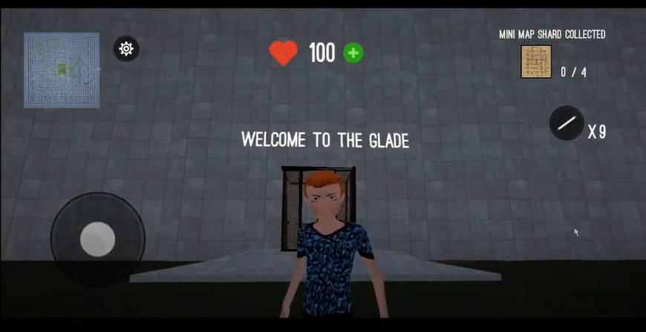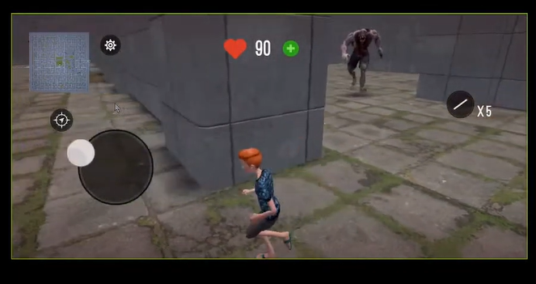

Pros:

* The sky and the wall texture are good and clear to see and identify
* There is different texture between grass and wall and similar to the movie maze runner
* It has a simplified mini-map and real time locate player location.
* A lift is transported at the start and the end of the game which pay tribute to the movie
* A light bar that allows you drop on the floor for bookmarking the direction of player
* Graphics setting is included to make the game compatible with less powerful phones
* The lobby music is energetic.
* Power-up and health boosts available by watching ads.
* The player and monster animation are fully animated and runs smoothly

Cons:

* There is no way to take the monster down (no trap and attack method)
* The map is too complex, you can’t win this game without screenshot and the map planned beforehand
* In this game it is easy to get lost but the monster keeps chasing you
* No achievement after you successfully escape.
* The lobby music is repeated and becomes annoying at a few times.
* You can go back to the laboratory as the lift doesn’t disappear after the start.
* The blood effect affects the camera vision and it never disappears.
* Mini map should update even though it is closed.
* The monster keeps following the player wherever the player is (even though the player is not in sight of the monster)
* There is no safe place or cooling down for monster chasing.
* The map is not randomly generated (same map every time)

Conclusion: Unlike the movie, the maze is fixed and only one objective. It is quite boring whilst the monster is too overpowering. This game uses unreal engine, this explains why the graphics and texture is rendered to perfectly match. The map should be more straight-forward and without any external tools for players easier to solve. My suggestion is to add a navigator and the ability to draw and highlighted in the mini map. The monster chasing is very annoying as I can’t pause and play the game in a relaxed way. I would add a combat system to allow players to kill and defend from the monster. For example, powerful weapons and armour protection and to be able to setup some trap like a speaker making some noise to attract the monster and confuse them. The monster that is killed by the player could drop some loot and clue. I would add some more NPC to assist the player and some more variants of monster. Furthermore, the ability to locate the monster in the mini map could help the player to avoid them. The blood recovery system and navigation system are connected to ads however the ad service is not working which is disappointing as the blood can’t recover and it affects the gameplay. I would suggest having some methods of healing yourself. Moreover, as the map pattern is fixed and complex to solve, player need to screenshot and plan the route before solving the maze. It is nearly impossible to solve it at one go or without planning. Blood effects should be minimal because it keeps showing on-screen affecting the whole gameplay.

Game 2: RPG-Maze

This game has a random map generator which is a bonus and delighted me a lot. This game uses a stereogram texture. The camera is free to move too.

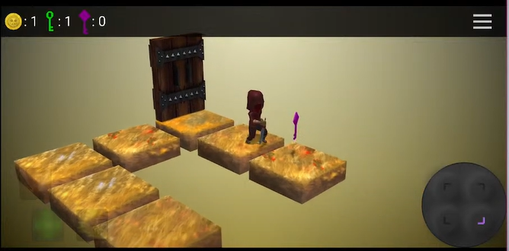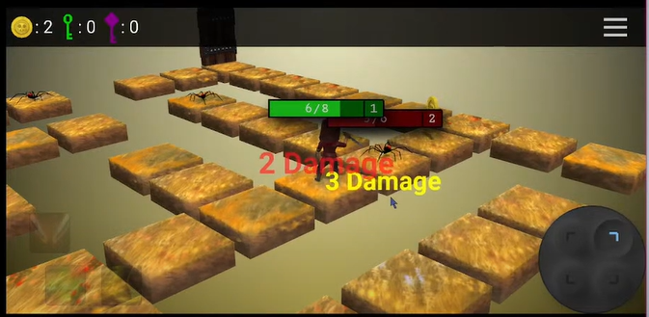

Cons:

* The input is hard to input and control as it is 4 separate buttons, and it is fixed at the corner which hard to reach
* Walking speed/ animation is too slow (better if timescale could double or Fast-Forward
* This game has no jump option which wasted a lot of time going to a sim.
* The damage of fighting is too random and unpredictable.
* The high pitch lobby music keeps looping and makes me feel annoyed.

Pros:

* Good UI – including joystick, health bar and health change text.
* Predictable monster movement
* Player can deal one more damage to the monster as the monster attack is delayed.
* The loading screen is fancy and separate from the main game.
* There is achievement and reward after finishing each level.
* The movement of the character walking is fully animated.
* Background music is included in the game.
* The setting has an option to turn off the music.
* The map is randomly generated even though it is in the same level
* Token and Power-up system [fire/ sprint/ heal system]
* Level preview function (provide a detail of number of monster and keys)

Conclusion: The objective of this game is quite clear. They are all located at the top with an icon. The tutorial is clear for players and players could easily understand and follow. The collection of the key is also the main objective of my game as it is used for opening the maze so I could use it as a reference. However, pattern of the key generation in this game is usually located at the furthest corner which means the player needs to take a lot more time to finish a simple task. Also, the character moves quite slowly, I would consider adding a speed up option for player. Although this game has the advantage of a delayed monster attack, it also has an unfair combat system because the damage is unpredictable which means it is a risk to challenge the monster in this game.

Game 3: Endless Maze Runner Survival 2

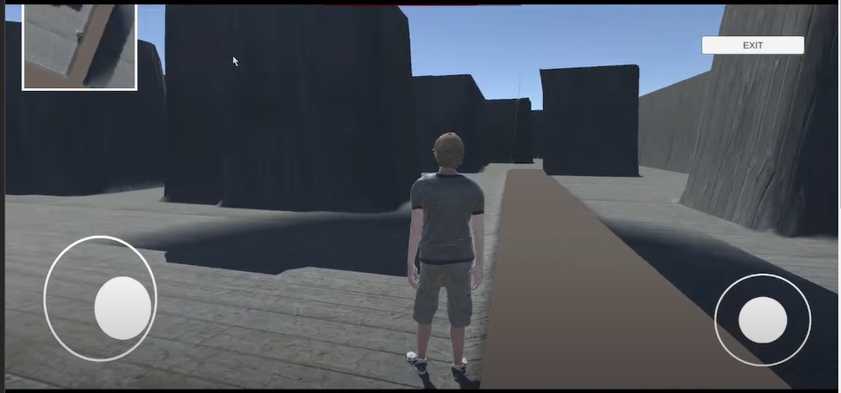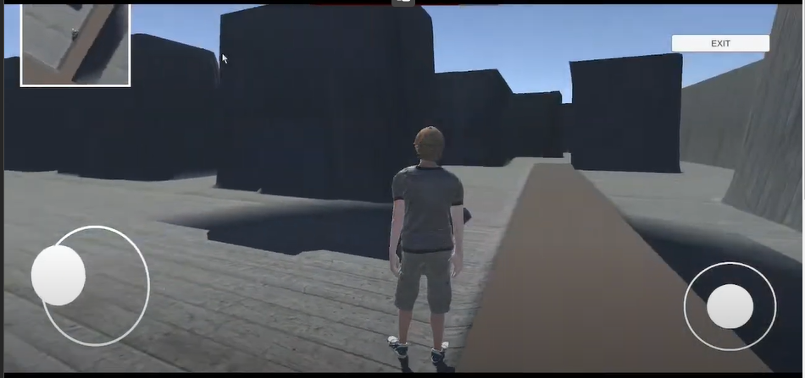

Pro:

* The game is playable and joystick control is quite good.
* The movement and turning could be a reference to my game.
* The mini map to show where the player is located.

Cons:

* The texture is too simple/ not attractive.
* This game has no interactive element, NPC nor monster.
* There are only 1 level in the game.
* It is impossible to find the exit as there are not any hints on the mini map or the game
* This game has no other objective and it is easy to get lost
* The camera can look through the wall in third person perspective
* There are too many ads in the game. When ads appear at start and end of the game
* There is no day-night shift, and the shadow of the wall is unrealistic as some of them are floating in the mid-air
* The position of the joystick cannot be adjusted which is not user-friendly.
* The speed of the character is too slow. It takes more than 15 seconds to walk to the finish line in a short distance.

Conclusion: The game engine, the setting and the map of this game is similar to my prototype. However, this game is barely playable. The mini map in this game could be improved as it is currently completely useless to solve the maze. But this game has quite natural and responsive animation while the character is moving.

Game 4- Maze RPG Dungeon

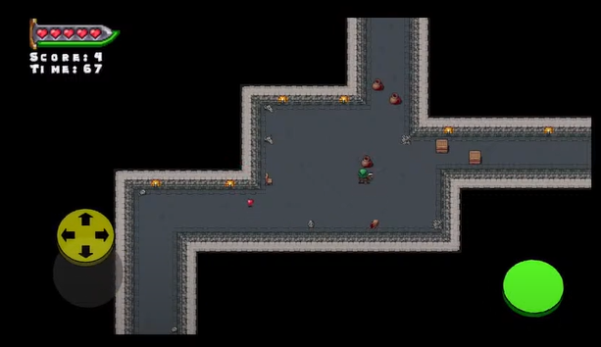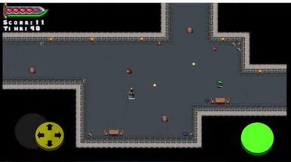

Pros:

* The text has cool effect and colour gradient.
* The button is 3D design.
* The wall and the floor are easily distinguished.
* Lots of additional/ extra entity in the game
* Tutorial is easy to follow and understand the mechanics.
* Count down timer. Player must finish the game before the time runs out and additional score is reward for the remaining time
* The game will automatically zoom-in in tiny area
* Random box is generated contains loots.
* The monster shoots fireballs which are predictable and can be avoid by controlling the movement of the player
* The health item on the floor is available to pick up and recover the health
* Hint pop up when there is an update on effect or health

Cons:

* The joystick does not response instantly. It needs times to “accelerate” the player movement.
* There is no setting menu, login menu, save menu and pause menu
* If you switch out and back to the game, you have to restart your level because it forces quit and doesn’t save the progress in the background
* If you get hit, you can’t move. Not ideal when escaping from a monster.
* No instruction on escaping the map no direction, no exit and mini-map.
* The distance of monster attacking is unclear.
* No way to counterattack of the fireball dispenser.

Game 5- Maze Runner 2D

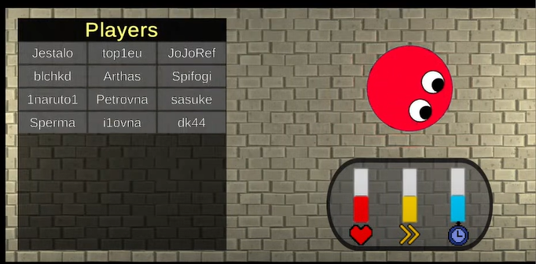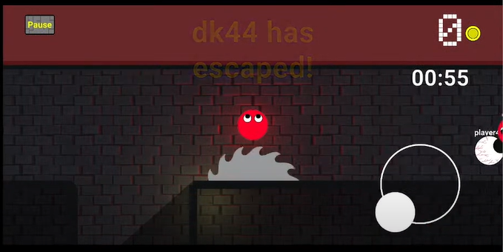

Pros:

* tutorial at the game start – (show dialog box and visible when introducing the UI)
* Exploring torchlight, entity is hidden unless the torch is on
* The lighting is varied in different area.
* Use the “eye” to tell player the direction of the character.
* Trap included in the game (circular saw and pressure plate which is hard to see
* There are coins available to collect in the game.
* One way movement only (like ice skating rink)
* There is no pause menu during the game.
* The joystick which controls player movement is located at right hand side.
* Vending system to trade character skin with coins.
* Every character has different ability (health, speed and time level)
* Character preview on waiting screen.
* System broadcast on the update of the game
* Power up could slow another player down
* Able to continue the game even if the player is dead by watching ads.
* Poison zone like PUBG is included to limit the area of player is included.

Cons:

* Fake multiplayer game (use AI moving algorithm to move)
* The time limit is too short.
* The circular blade trap is too fast and large. Very hard to escape from the trap.
* The trap should have more time for player to react
* No pause menu button

Conclusion: This game should have a pause button. It is not a multiplayer game, and it is paramount for people who play in their spare time. However, the game is quite fully developed, the AI script movement acts like a real player. Although it has a tutorial at the beginning of the game, the direction of the map is unclear and you are unable to reach the finish line. Adding a mini-map could help the player to navigate a lot better.

Game 6 – Labyrinth Legend

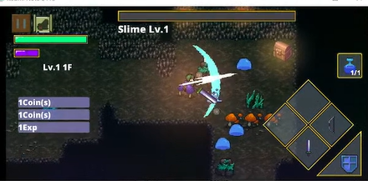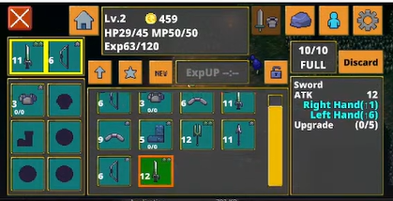

Pros:

* Selection of language
* Google play integration reduce the time of register and login
* Personalize the game by using the name user login
* Setting is all-rounded, including audio, field of view and quality setting
* Statistics and achievements are available in the setting menu
* Layout and size of joystick can control by the user
* The game store the game session both local and cloud service
* Staff credit included in the game
* The storyline of the game is mentioned before the game start
* The control is responsible and interactive
* The character movement is fast and footprint is shown for realistic
* The joystick is not fixed in the same location
* Predictable and avoidable monster attack by using (!) to alert player
* The damage deal to the monster is high and
* The attack range is acknowledge with the animation
* Able to attack from the monster with no recharge/ cooldown needed
* There are shield as a power-up to block any damage from the monster
* Different ways to restore health by drinking elixir and on next game start
* Could replace another weapon like bow in inventory menu
* Weak but abundant monster
* Monster will drop the key requires to open the door
* Monster health bar is always shown on top of the monster
* Monster will only chase and attack player within a certain range
* Knockback will be perform when monster hurt the player
* Hint is pop up with news on inventory or experience earned
* Use portal to teleport to the next level
* Random loot from the ground by removing the grass with sword
* Inventory includes sort function
* A lot of NPC provide interaction dialog and objective to player
* Comparison on damage and speed of two different weapon is shown
* The pause menu separate setting and inventory using multi- tab
* Monster will drop some coins after it is dead

Cons:

* Setting could be organised
* The setting menu and inventory is combined with the pause menu
* No map to solve
* There is only one objective and player cannot reach the escape of portal before killing all of the monster

The gameplay of this game is underrated and combat system, monster behaviour and the setting of this game could be a reference to my game. The joystick could be dynamic so it is more user friendly to mobile player. There should be different weapon choice, comparison between you weapon and inventory sorting should also include in my game. However, I will add more objective and power up to my game to enhance the gameplay of my game.

Game 7 – Stumble guys

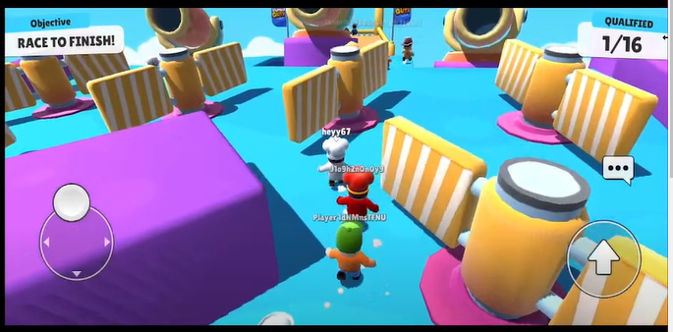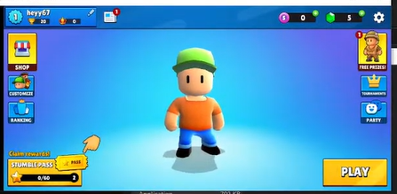

Pros:

* Multiplayer is smooth and responsive in real time
* The game session could be self-hosted by the player
* The host of the session will be transfer if the original host is left
* The achievement system is fully integrated to the main
* Personalise by changing the name and different clothes customization
* Shop system integrated with daily bonus – attract player to login and play everyday
* Leader board system included and can be sort by region of the world
* Maps are randomly selected with animation
* Realistic physic system and animation of player is added
* The cartoon UI is user and child friendly
* Powerup are predictable by the texture (bouncer, spring or cannon)
* The weather affects the gameplay (Icey weather will walk slippery)
* Game-over page will show the reward gained including the placement, coin and experience
* The game is straightforward and tutorial is not required for this game

Cons:

* Requirement of stable network connection
* The trap can only avoid precisely and with skills

This game focuses on the multiplayer experience and realistic physics system which inspire me on the multiplayer session of objective and the realistic movement player needed. Leader board sorting is also a good idea as player would like to know different performance and statistic on different criteria

### 1.2.1.5 Prototyping

1. Movement

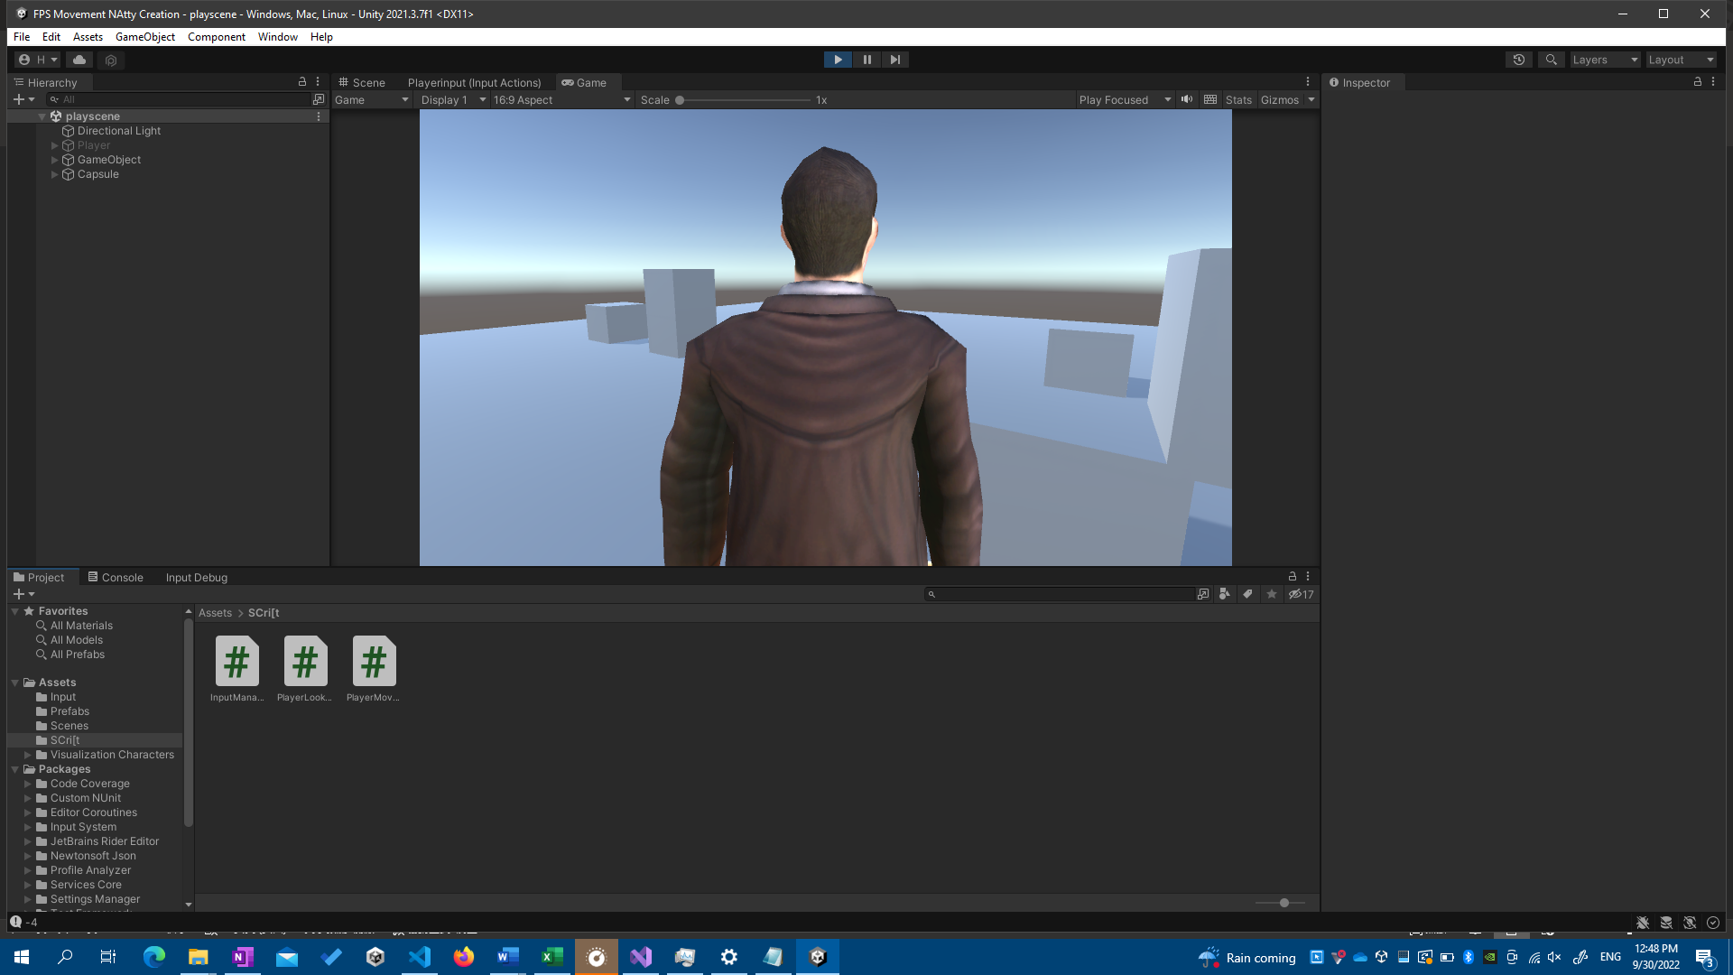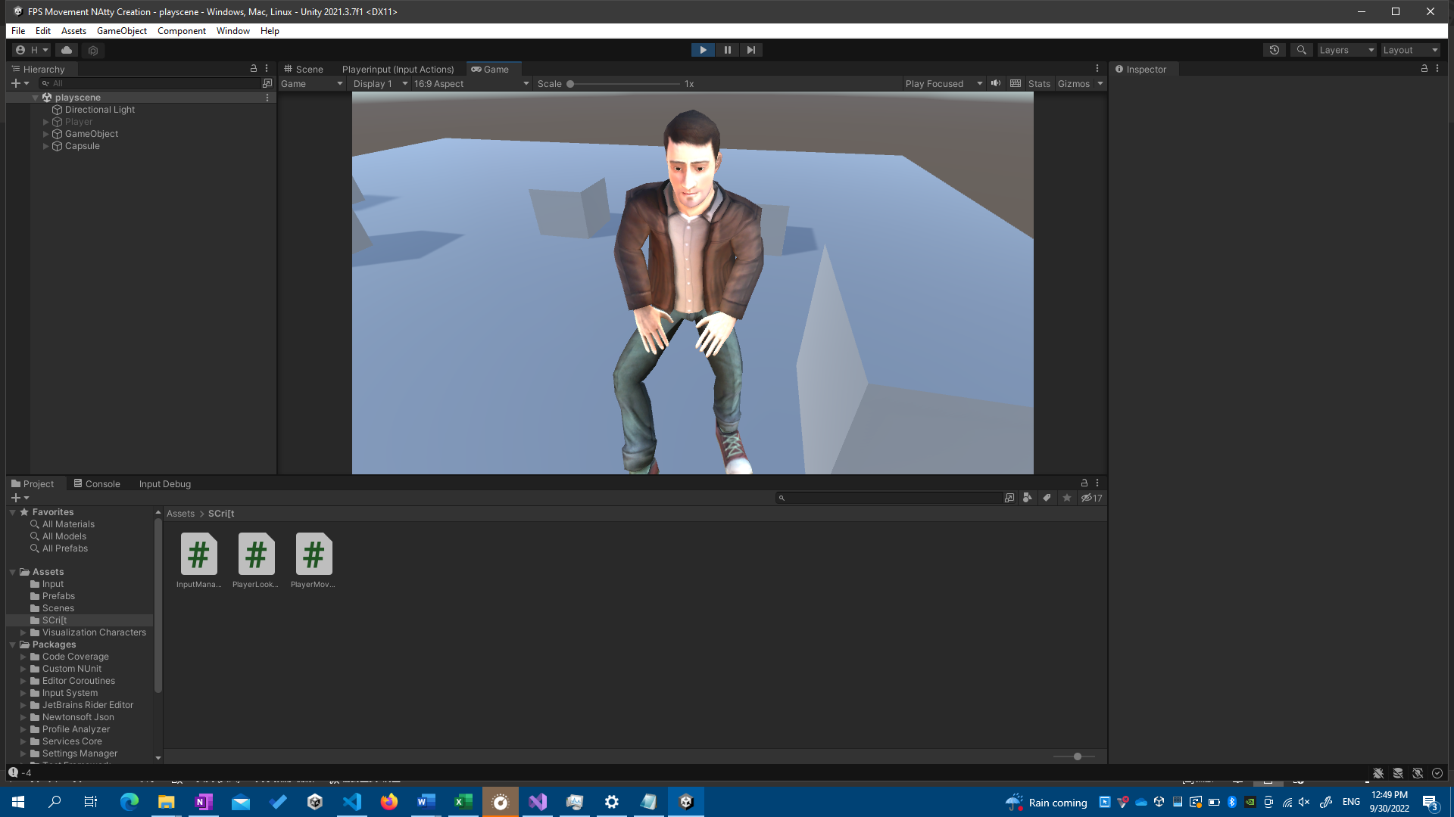

When I started coding my project, I needed to get comfortable with the tools, which involve the C# language and the Unity Engine. In order to move and gaze about, I have followed a lesson on movement control using a computer mouse and keyboard (W, A, S, D, and spacebar). To demonstrate what I learnt from the instruction, I have also implemented a jump action. When a movement, such as walking or jumping, was triggered, animation was added and altered. To make a seamless transition, I utilised Unity's built-in Finite State Machine for Animator.

1. maze game (PC)

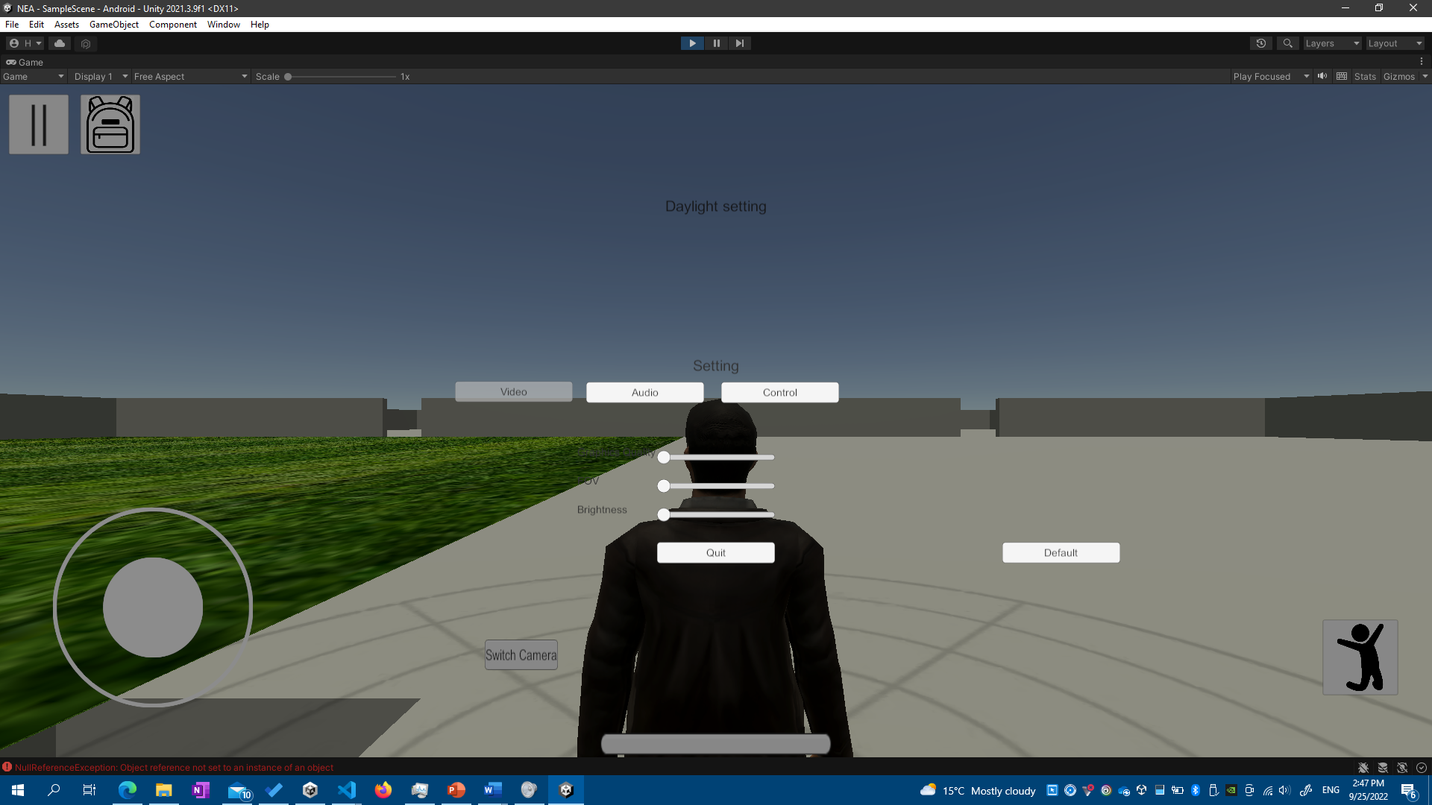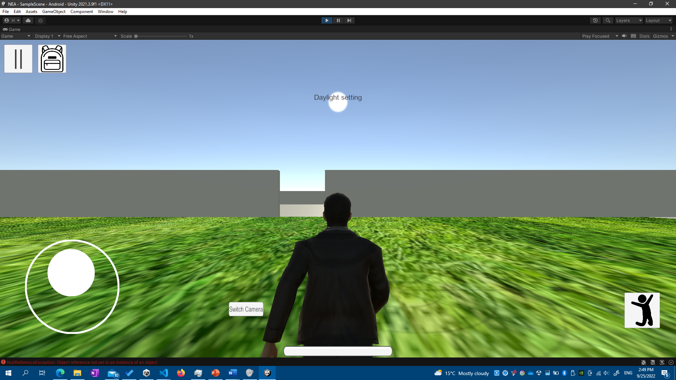

This is my 3D labyrinth game prototype. This map was created using the modelling software SketchUp. The model had been successfully imported into Unity. Except for the texture, the model is totally compatible with Unity Engine. However, a native Unity model needed to be replaced so I may apply texture to different parts of the model. This prototype includes the Main Menu, Pause Menu, Login and Registration Menu, and Inventory UI. This basically entirely covers the Interface of my game.

The setting function for customising the game in player presence is operational. There are multiple tabs for various setting categories. The joystick size and rotation sensitivity may be adjusted using the slider. To make this game mobile device suitable, the movement is modified from the sample game, and a joystick and detect screen touch input are added to make the game more touch-friendly. The joystick allows the character to move/walk and spin around by moving inside the right half of the screen. The actual game, like this game and the game above, will include animation.

## 1.2.10 Analysis Data Dictionary

|  |  |  |  |  |  |
| --- | --- | --- | --- | --- | --- |
| Field Name | Field Purpose | Field Type | Field Size | Example Data | Validation |
| Record_ID | Index of all data | Int | 11 | 0,1,2 | Primary Key, Unique |
| email | The login detail of user | String | 255 | [admin@shalev.ml](mailto:admin@shalev.ml) | Not blank, Unique |
| password | Login to verify user | Varchar | 255 | Ss12354678 | Not Null |
| username | Display playerName on leaderboard | String | 255 | Shalev Lau | Not Null, Unique |
| levelName | The level name | string | 50 | Easy | Not Null |
| multiplier | The reward of difficulties | float | 11 | 1.4 | Not Null |
| score | The number of monster player has killed | Int | 11 | 8 | Not Null |
| time | Time required to solve the maze | int | 11 | 50 | Not Null |

## 1.2.11 Data File Size /Volume

The total database file size including the data, index, overhead. The file size of Progress table including five 11-digit of integer requires approx. 8.0 Kibibytes. The file size of Player table which includes four 255-digit of string, one 20-digit of string and one 11-digit of integer primary key requires approximately 3.0 Kibibytes. The file size of Level table including 11-digit of integer primary key, float and 50-digit of string needs 2.285 Kibibytes.

## 1.3 Specific Objective

### 1.3.1 Splash Screen

1. The name of the game should be appear before the game starts
2. The name of the producer should appear before the game starts
3. A warning of copyright of the game needed to be shown in the loading screen
4. A Loading Screen should be shown after the names above is shown
5. Loading Screen needs to be clickable after the names shown
6. Main Menu should be loaded after the loading screen is clicked

### 1.3.2 Main Menu

* + 1. A introduction image should fade out before the Main Menu is shown
    2. A pop-up screen should be pop up to alert player to login to save the progress into the Leaderboard
    3. There should be 5 buttons on the screen, including Continue, Start Game, Leaderboard, Setting and Quit
    4. All 5 buttons listed in 1.3.2c should be able to open different panel when clicked
    5. The continue button should be disable if the game haven’t run before
    6. Login state should be on main menu remind the player which account it is logged in

### 1.3.3 Setting Screen

* + 1. Login Screen should pop up to make it more convenient to login
    2. The Setting Screen should have 5 categories, including Audio, Video, Control, Graphics and Login
    3. All 5 categories tabs listed in 1.3.3b will show corresponding setting category
    4. Default value should be set before if setting is never open/ configured before
    5. Video Option should contains the Field of View of camera and minimap setting
    6. Audio Option should contain SFX and Music Volume Setting
    7. Graphics Option should contain settings of Quality level and brightness
    8. Control Option should contain settings of the size of joystick and Sensitivity of turning around
    9. Settings value should be loaded after the Setting Panel is closed
    10. Value of settings should be saved in order to retrieve on next game runs

### 1.3.4 Quit Panel

* + 1. The quit panel should show 2 buttons including Quit Button and a Cancel Button
    2. The game should be quitted after Quit Button mentioned in 1.3.4a is clicked
    3. When cancel button is clicked, quit panel is disabled and return to main menu

### 1.3.5 LeaderBoard

* + 1. A leaderboard panel and 4 selection columns including player username, level, score and time used needs to be available for player click
    2. An instruction will pop up talking about the sorting and statistics players can access
    3. Different columns will be sorted using merge sort based on user selection
    4. Leaderboard data needs to be automatically updated
    5. When player performance button is clicked, the level score of each player will be shown
    6. When all statistic button is clicked, best player of each level and average score will be shown

### 1.3.6 Login & Register

1.3.6.1 Login

1. email field must not be blank
2. password must be longer than 8 characters
3. wrong password prompt will be shown if the password or username entered doesn’t match with the detail in database
4. A login successful prompt will be shown if both password and username entered correctly and match with the data in database
5. When the close button is clicked, the login screen will be disable
6. Login state will be automatically update in the main menu screen
7. The login state will be saved in local file and automatically login in when game restarted

1.3.6.2 Register

1. Username field must not be blank
2. Username field must not be more than 20 characters
3. Email field must include an @ symbol and follow correct email regex
4. The password field must not be blank
5. The password field must be more than 8 characters
6. The password field must contains one uppercase, one lowercase and one number
7. The password field must not be contains common character such as “1234” and “pass”

1.3.6.3 Welcome back

1. If the game is logged in, the welcome back screen will replaced the login screen
2. The username logged in will be shown on the screen.
3. The play button and the close button will be confirming the login detail is corrected.
4. The login state will be cleared and return to the login screen if the not you button is clicked

### 1.3.7 Start Game Save Slot Selection Panel

1. Data of the slot will be deleted and the continue button will be disable in the main menu
2. Pop up will show the detail of last play and the current score and time used to spend on the game and index of the slot
3. Game Save Status can be delete through a cross button and the continue button will be disable if deleted successfully
4. Game will start when either slot is clicked , loading screen will appear

### 1.3.8 First Time

* + 1. Animation should played after the screen is loaded
    2. Difficulty panel should appear after the animation ended
    3. There should be 6 level in the difficulty selection

### 1.3.9 Character Selection

* + 1. Player can choose from the 4 different characters
    2. Detail of player will show when the pop up button is clicked
    3. Main menu will be returned after the player has confirmed their character selection

### 1.3.10 Maze Generation

1. The maze should generate and saved before the game start
2. The maze will generate randomly in every new game
3. The maze will be more complex if the level increase

### 1.3.11 Loading Screen

1. Loading bar and text will indicate the progress of scene loading
2. Loading text will be change every 3 second to entertain players

### 1.3.12 Main Game

1. Player is able to switch between the 1st and 3rd person camera
2. Left joystick needed to be able to control the movement of character
3. Right joystick should be able to control the direction of movement
4. Jump action will be performed and movement will disable when the jump button is clicked
5. Crouch action will be performed and movement will be slow down when the crouch button is clicked
6. The animation of the player will loop between walking and idle
7. The time of the game will be shown on the screen
8. The kill count of monster is shown on the screen
9. The camera will automatically follows the player

### 1.3.13 Weapon

1. The attack icon will change to the current weapon selection
2. When one of the weapon slot is clicked, current weapon will change to the clicked weapon
3. When the player collide with the moving blade, it will deduct player health
4. The axe will throw forward when axe selection button and attack button is clicked
5. Trap will be placed when current weapon is set to trap and attack button is clicked

### 1.3.14 Monster

* 1. The health of the monster will be deducted when the axe or trap collided
  2. The monster will be dead when the health is below 0 and not dealing any damage to player
  3. When the monster spotted and moving toward the player, a warning banner will pop up



* 1. The monster will only chase player within certain distance
  2. The monster will start attacking player within a small distance
  3. When the monster is attacking player the player health will be decrease
  4. Random type of monster will be spawn every day
  5. Monster should use shortest path algorithm to chase player
  6. The monster should drop a key or other loot when they are dead
  7. The monster health is shown on the top of the monster
  8. The monster will be crushed to dead if it doesn’t have enough time to pass through the gate of the maze
  9. Monster attack will be cooled down before the next attack

### 1.3.15 Maze

* + 1. One of the gate will be after the game started
    2. The next opening gate will be changed every 24 hours
    3. When the skip button is clicked, the next opening sequence will be opened
    4. The maze opening sequence will be shown on the screen
    5. The player should not be able to pass through any wall and maze in this game
    6. The maze should contain a walkable path to reach the exit side

### 1.3.16 Exit

1. The exit is located in one of the maze zone only
2. The exit gate should be open when the player typed in password correctly
3. Player should hold the key in order to make the password screen visible
4. The progress of the game will be deleted as the level is finished

### 1.3.17 Health

* + 1. Health will be +10 when the heal button is clicked
    2. At the start of the game, the health is at the maximum value
    3. Animation will be played when the health value is changing
    4. Game over screen will show up when the player health is less than 0

### 1.3.18 Pause Menu

* + 1. The menu will show up when the button is clicked
    2. There are 2 buttons in pause menu, return and quit the game
    3. The pause menu will close when the return button is clicked
    4. When quit button is clicked, it returned to the main menu and progress will be saved in local file
    5. The time counter of main game should be paused

### 1.3.19 Game Over

* + 1. The screen will contain following elements, whether the player passed, the time used by the player, the difficulty level and the monster player killed and continue button.
    2. Login screen may appear if the player haven’t login yet
    3. The close button of login screen is disable to forced player to login and save the score

## 1.4 Additional Objectives

### 1.4.1 Path Finding

1. The mini-map should show the path of escaping the maze using Dijkstra

### 1.4.2 Visual Improvement

1. Blood effect will show up when the monster is hurt

### 1.4.3 Monster

1. The monster should setup some trap on the floor that constantly deals damage to player

### 1.4.4 Special Feature

1. Power-up should be included which stealth, speed increase and strength increase
2. In sunny day, the player will received speed boost
3. Footprint should be left on the floor

### 1.4.5 Quest System

* 1. Objective and quests should be added in the game
  2. Rewards of weapon and coins should be given after finishing the quest

### 1.4.6 Achievement System

* + 1. Achievement and rewards should be given once player achieve an achievement
    2. The count of achievement target will be increase polynomial

### 1.4.7 Inventory

* + 1. The inventory panel should be open when inventory button is clicked
    2. The inventory panel should include 4 button search, sort, slot1 and slot2 buttons
    3. The inventory should include crafting table when the player is near to a crafting table
    4. The crafting table should support undo function

### 1.4.8 Pick Up

* 1. When the player walks into the range of the item, pickup panel will pop up
  2. When the pickup panel popped up, player can pick up the item listed if the inventory is not full
  3. When the player dropped the item, the item will left on the ground

### 1.4.9 Music

* 1. The Setting should be able to change the volume of music
  2. SFX and background music are separated
  3. SFX should be played when the player get hurts and movement has done
  4. Music should be played in the main menu

### 1.4.10 Rewards

* 1. Rewards is given for weekly login
  2. Bonus box (loot) is given at the game start

### 1.4.11 Online Service

* 1. Login with social media SSO should be an alternative way to login the game
  2. Option to share the screenshot to social media should be added
  3. Current game state should be automatically upload to Google Drive or OneDrive

### 1.4.12 Multiplayer

* 1. More than player can be played and co-operate in the same game session
  2. The player should be the host of the game server
  3. If the host player has left the game, the host will be transferred

### 1.4.13 Ghost System

* 1. A splitting image of player in the previous round will be shown as a semi-transparent model in the game

### 1.4.14 Wooden box

* 1. Wooden box provide 16 slot for storing extra items player has
  2. The wooden box must be able to locked to prevent other player grief from the box

### 1.4.15 Vending Machine

* 1. Vending machine should be include in the pause menu
  2. Player can spent their coins in the vending machine buying rare weapon, special character and medicine

### 1.4.16 Terrain

1. The terrain amplitude is generate using Perlin noise map

### 1.4.17 Action Replay

* 1. There is a rewind button to go back to previous state
  2. Playback is available for killing the boss monster

### 1.4.18 Player Profile

* 1. Player name, XP and level will be shown on the player profile page

### 1.4.19 Database

* 1. Player password will be stored in hash and salt to enhance the security of database

## 1.5 Proposed solution

My project will be implemented by C# and Unity Engine using Visual Studio Code and JetBrains Rider as my IDE. Unity Engine is a powerful tool to create either 2D or 3D games and is interchangeable. Secondly, C# and Visual Basic shares the same library using Microsoft .NET framework which the syntax and logic is similar, so it is easier for myself to learn C#. Thirdly, Unity support multi-platform like android and WebGL so I don’t have to switch engines to switch platform. Lastly, there are a lot more tutorials and resources for Unity compared to other game engines like Unreal Engine.

# 2. Design

## 2.1 High-level overview

### 2.1a System flowchart (whole diagram)

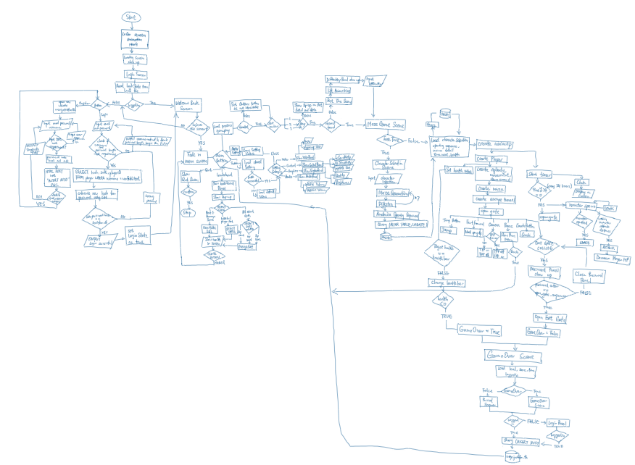

### i) Login Screen and splash screen

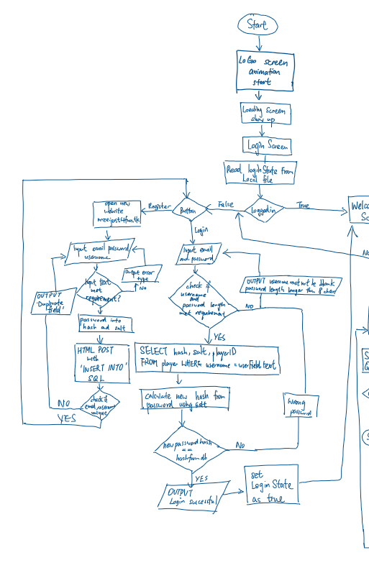

### ii) Main menu screen (Leaderboard, Setting, Quit and Start Game)

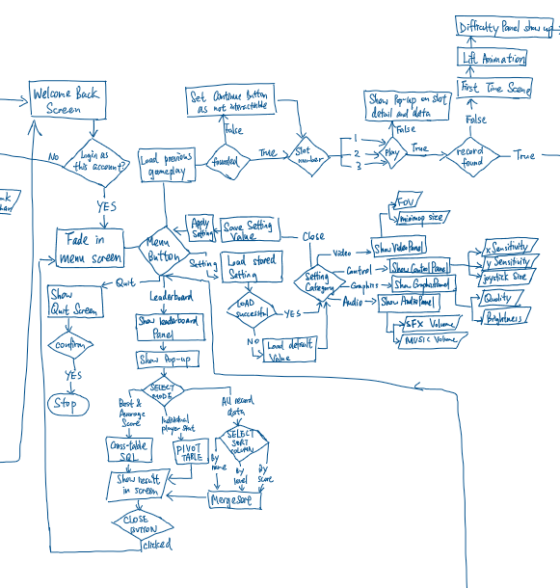

### iii) Maze Game

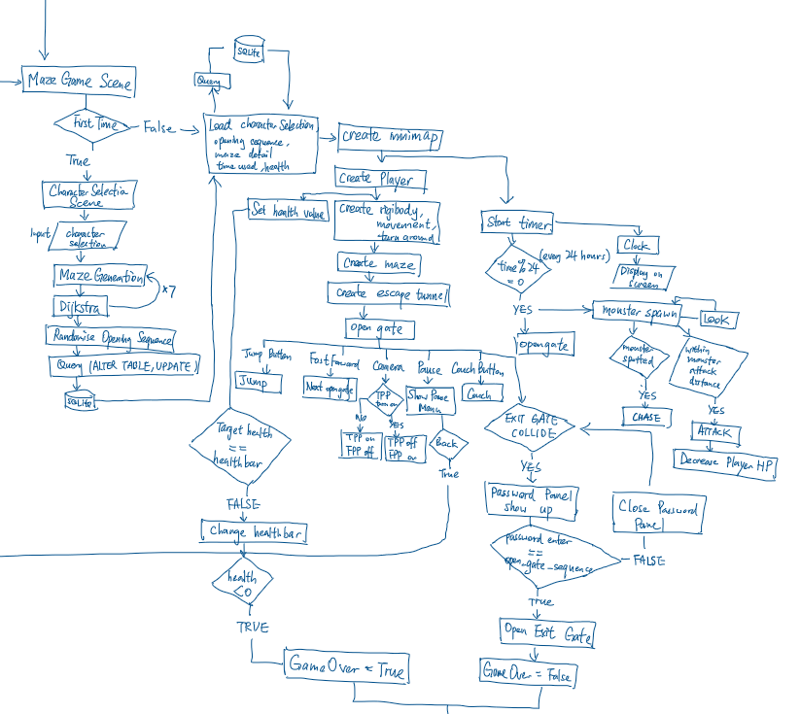

### iv) Game Over Screen

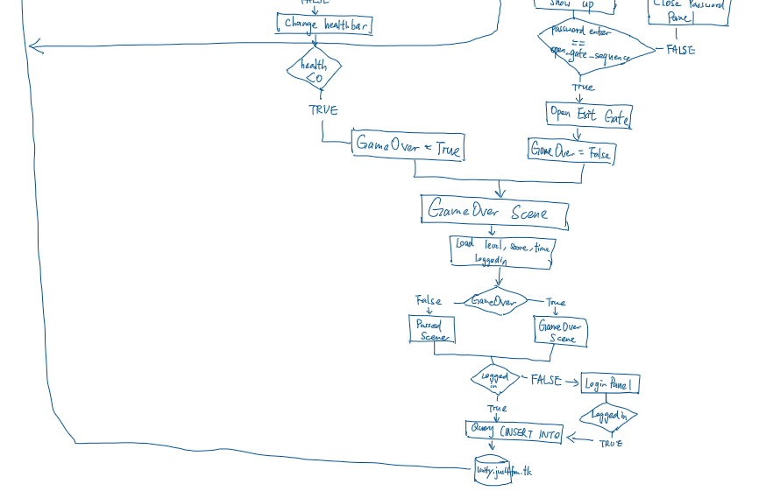

### 2.1b Data Flow Diagram

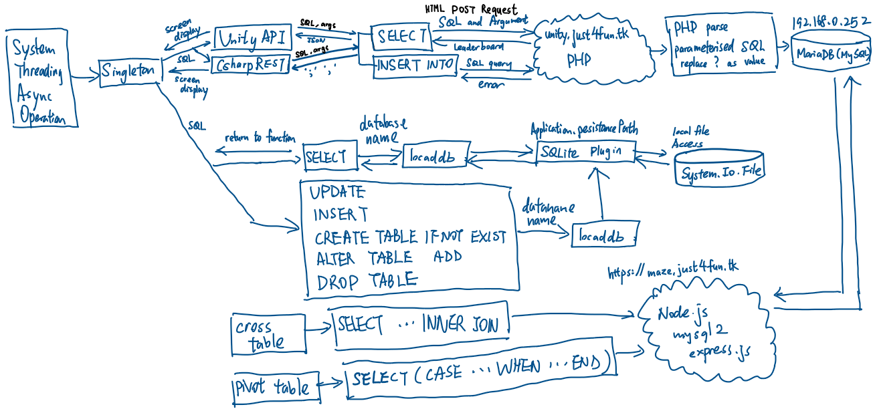

## 2.2 Modular in structure of system

### 2.2a Site map

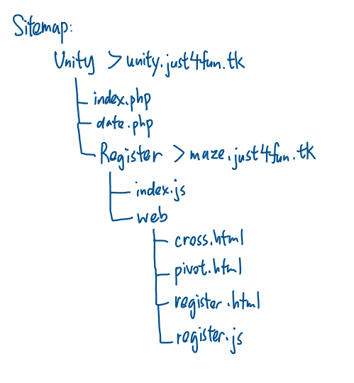

### 2.2b System chart

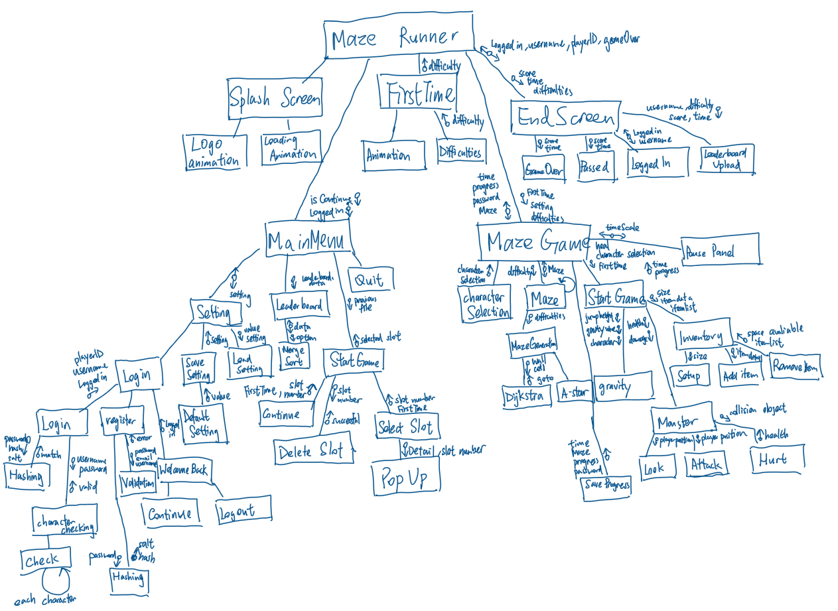

### 2.2c Table of Class

Algorithm

this folder contains all useful algorithms such as sorting and hashing. These algorithms will be easily accessible by create a new instance using composition class relationship.

|  |  |  |  |
| --- | --- | --- | --- |
| Class | Description | Attributes | Methods |
| BinarySearch | This class contains binary search function which user enter the list and search item and it return the position of the list. |  | Search() |
| Checking | This class contains character checking for login screen for data integrity |  | Check() |
| CQueue | This class contains a combination of circular queue and linear queue | _queue :int []  _circular :bool  _frontofqueue :int  _rearofqueue :int  _numberofitem :int | CQueue()  Enqueue()  Dequeue()  Peek() |
| gravity | This class contains a base function of the gravity function for both player gravity and entity gravity | _grounded :bool  gravityacceleration :float  _jumpgravity :float  _gravityspeed :float  _orginal :Vector3  _isUpJumping :bool | Update()  gravitySetting() |
| hashing | This class contains a hash algorithm converting string into integer using hashing algorithm and store in hash table. Linked list is used when hash table has more than one same key value |  | Convert()  HashTable() |
| lList | The purpose of the linked list is to serve hash table to prevent error happened if the hash table has more than one key value(index) | dataNmemoryloc :int  Headloc: int | lList()  AddHead()  GetNextPointer()  GetBlockData()  AddFoot()  Search()  Traversal()  SearchPriority()  AddWithPriority()  AddValue() |
| MergeSort | This class contains a merge sort algorithm. It require input of a list and order column then uses recursion to divide and conquer the data |  | MergeSort()  Merge() |
| Projectile | This projectile inheritance from the gravity class. It is used for entity (axe, weapon) gravity | Yacc  Speed  Gravity  Velocity | Update()  Shoot() |
| Stack | This class contains a stack function which follows First In Last Out. And include a contains function to search through the stack | _stack_arr :object[]  _pointer :int | Stack()  Push()  Contains()  Pop()  Peek() |

First Time Scene

The following scene only runs when the game slot is new

|  |  |  |  |
| --- | --- | --- | --- |
| DifficultyPanel | This Panel show up after the list animation has been played. Player choose from 7 Level options and continue to main game | Diffi : Slider | Start()  Load()  Update() |
| FirstTimeMan | This script start the animation when the scene loaded | Loader :GameObject  _animator :Animator | Awake()  Update()  LoadScene() |

Maze Scene

|  |  |  |  |  |
| --- | --- | --- | --- | --- |
| CharacterDataBase | This class uses for storing multiple characters | | Characters :characterSpecification[]321 | GetGameObject() |
| characterSpecification | This class is a serializable object which uses as a template of data structure | charImage :Sprite  charName :string  charDescription :string  speed :float  InventorySize :int  actualObject :GameObject | |  |
| Charcard | This class store in character selection card to deal with the button onClick in GameObject | Popup :Button  Selection :Button | |  |
| Inventory | This class manage the player’s inventory. | InventoryItem :Structure  itemDetail :item  quantity :int  inventoryItems :InventoryItem[] | | Start()  Setup()  Pickupitem()  Removeitem() |
| Item | This class is a serializable object which provide and template on structure of data storing. | maxStack :int  itemImage :Image  obj : GameObject  itemName : string  Weight :float  Damage :float  Weapon :bool  Throwable :bool  Shootable : bool  pickupScript : PickUp  triggerradius : float | | OnEnable()  OnTriggerEnter()  OnTriggerExit() |
| ItemsObject | This class create a instance of item and run initialise function of an item |  | | Start() |
| Slot | This class is located in the slot inside the inventory. It define the behaviour of the slot | mainSlot :bool  itemdetail : item  stacksize :int  stacksizeUI :TMP_Text  itemImage : Image  frame : Image | |  |
| Djk | This class contains a Dijkstra algorithm and return a list of walkable shortest path | Wall: List<string>  Cell :MazeCell[]  Unvisitedcell | | Djkinit()  Search()  Calcost()  Obcheck()  Sidebar()  AvaliableCell |
| Goto | This class receive the path from Dijkstra and control the movement of monster | Shouldmove :bool  Pos: Vector2  Speed :float  Hello : GameObject | | Goto()  Update()  Move() |
| Maze | This class create a basic model for maze generation to start | _sizeX :int  _sizeZ :int  _cellPrefab :GameObject  _walls :List<string>  _cells :Mazecell[,]  _wallPrefab :GameObjectq | | Generate()  CreateCell() |
| Mazecell | This is the class in each cell in the maze. It store variable for Dijkstra, A* and DFS maze generation | Visited :bool  Dir : List<string>  Djkmincost :float  Djkprevious : Vector2  Djkvisited : bool  djkdirX : int[]  djkdirZ : int[]  ghost :float  hcost :float  fcost :float  Aprevious :Vector2  Avisited: bool  Adir: bool[] | |  |
| MazeGeneration | This class use DFS as algorithm of maze generation by eliminating the wall | _myParent : Transform  Wall : List<string>  Cell : Mazecell[,]  Stack1 :Stack | | Run()  BuildMaze()  Checkdir() |
| WallCell | This class contain the behaviour of the wall |  | | Start()  Update |

Monster

|  |  |  |  |
| --- | --- | --- | --- |
| BigGreiver | This class is derived from monsterbehaviour and adjust the damage to fit as Large griever |  | Update() |
| Blade | This class control the blade spinning and deduct player HP | rotateSpeed : float  Scale : float | Start()  Update()  OnCollisionEnter() |
| IMonsterConfig :interface | This interface contains the basic method of monster | Health: float  Location : Transform | Look()  Chase()  Dead() |
| MonsterBehaviour | This class contains the default monster behaviour | _health : float  _location : Transform  _monsterloc : Transform  char1: GameObject  _animator :Animator  isDead : bool  isRunned :bool  _ins : MazeManager | Awake()  Start()  Update()  Look()  Chase()  OnCollisionEnter()  Dead() |
| SilverFish | This class is derived from monsterbehaviour and adjust the damage to fit as silverfish |  | Start() |
| SmallGriever | This class is derived from monsterbehaviour and adjust the damage to fit as small griever |  |  |
| Movement | This class handle the left joystick as the movement of player and derived from gravity class for gravity of player | Joystick :Joystick  Move : Vector2  Wallspeed : float  isCrouching : bool  crouchwalk : float  crouchheight :float  jumpheight: float | Start()  Update()  Touchmovement()  Crouch()  Jumpbutton() |
| PlayerAction :Interface | The interface contains the basic method that playerSetup should cotains |  | PlayerMove()  PlayerLook() |
| PlayerSetup | The class contains the setup of the basic feature including movement and turning around of the player | Timer : float | Start()  Update() |
| Switchcam | This class handle the switch button on switching perspective of camera | _cams :Camera[] | ChangeCamera()  Start()  Update() |
| toucharea | This class control the turn around joystick on the UI | Touch :GameObject | Start()  Update()  Raycast()  GetTouch() |
| Turnaround | This class handle the turnaround of the player | _cam :Camera  Dyn_joy : Joystick  xSpeed :float  ySpeed :float | Start()  Update() |
| Circular | This class handle the outermost wall and the position of exit tunnel | Center :Vector2  Radius : float  StartingPoint : Vector2  meterWidth: float  repeat :float  angle :float  objectToRotate: GameObject  rotationPoint :Vector3  rotationSpeed: float | Start()  Rotate() |
| Clock | This class handle the daylight and the time of the game. | Light :Light  Rotate :Vector3  Time :float  Text :TMP_Text  Date :int | Start()  FixedUpdate() |
| Escapecontroller | This class retrieve the game data after gameOver and show on screen | Time :TMP_Text  Monster : TMP_Text  Difficulties : TMP_Text  gameOverPanel : GameObject  PassedPanel :GameObject  mainPanel : GameObject  loginPanel :GameObject  CloseButton : Button  Username : string | Start()  Update()  Upload()  ContinueButton()  Back() |
| exitTrigger | This class handle the change of scene in exit tunnel | Exit: GameObject  passwordPanel : GameObject | OnTriggerEnter()  DestroyWall() |
| gameOver | This class handle the UI of the gameOver screen |  | OnTriggerEnter() |
| Heal | This class handle the heal button by increasing player HP |  | Start()  Update()  OnTriggerEnter() |
| mainCharacter | This class handle the weapon selection and represent the character. | currentSlot |  |
| MazeManager | This class control most of the function in the game. Including maze generation, character and the exit gate of the game and game save feature. | characterUI : GameObject  empty : GameObject  characterSelectionUI : GameObject  mainchar : GameObject  cams :List<Camera>  player :GameObject  character : characterSpecification[]  currentselection : int  currentAttackSelection :int  selectcharButton :Button  invent :Inventory  _angle : int  _monsterKilled : int  Open_gate_order : CQueue  Opennow:bool  Playerpos :Vector3  _setting :Setting  _password : string  Sprites : Sprite[]  spriteSlot1 :Sprite  spriteSlot2 :Sprite  attackSelection : Image  startAt : TMP_Text  NextGate : TMP_Text  Nextmonster : TMP_Text  Counting :TMP_Text  monsterPrompt :TMP_Text | Dead()  spawnMonster()  Awake()  MonsterPrompt()  Start()  ShowCharacterPopUp()  Selection()  Maze()  StartGame()  OpenPassword()  FirstTime()  SaveLevel()  Attack()  changeAttack()  heal()  openGate()  Back()  UpdateScore() |
| Minimap | This class handle the mini map of the main game | Minimap_cam :Vamera  Texture :RenderTexture  Img: RawImage | Setup() |
| onLoadMaze | This class initialise the game when the maze game loaded |  | Awake()  Update() |
| Open_gate | This class handles the maze gate of the game and the animation of opening | M_left: Transform  M_right: Transform  Back; Transform  Open: bool  Speed: int  mVecRIght_OpenPos: Vector3  mVecRIght_ClosePos: Vector3  mVecLeft_OpenPos: Vector3  mVecLeft_ClosePos: Vector3 | Update() |
| passwordPanel | This class handle the exit gate of the maze by user entering password | Inputtext :TMP_InputField  Password :String  Done :bool | Start()  Update() |
| Pause | This class handle the pause menu and the option provide in pause menu | Leader : LeaderBoarddata | Awake()  Start()  Update()  timeChange()  Open()  Close()  SettingPause()  LeaderboardPause()  Back() |
| PerlinNoiseMap | This class is used for creating the uniqueness of the safe zone area | Width: int  Height :int  Scale :float  Persistence :float  Lacunarity : float  Octaves : int  noiseMap: float[,] | Start()  Generate() |
| PickUp | This is the handling class for the slot of pick up panel | Items : List<Item>  _selectionSlot:PickUpSelectionSlot | Start()  Update()  Toggle |
| PickUpSelectionSlot | This is the User Interface handling for the pickup class |  | Start()  Toggle() |

MainMenu:

|  |  |  |  |
| --- | --- | --- | --- |
| MenuPanels | This is the abstract base class for menu enable. | _menu :GameObject | Awake()  Start()  ShowHide()  Function() |
| QuitMenuPanel | This class handle the quit menu |  | appQuit() |
| SlotSelectionPanel | This class handle the start game button and detect the save existence | filePath | Start()  SavefileSelector()  DeleteSlot()  popUpDetail() |
| AudioSettingPanel | This class represent the audio setting panel |  | Start() |
| ControlSettingPanel | This class represent the control setting panel |  |  |
| GraphicsSettingPanel | This class represent the graphics setting panel |  |  |
| Setting | This class load and save the setting stored in local file and apply setting in the game | Dbname :string  filePath :string  xSenS :Slider  ySenS :Slider  MusicVolS :Slider  sfxVolS :Slider  cameraFOVS :Slider  minimapSizeS :Slider  joystickSizeS :Slider  graphicQualityS :Slider  brightnessS :Slider | Start()  Setup()  LoadSetting()  SaveSetting()  UpdateSetting() |
| SettingManager | This class handle the buttons of the setting tab | _audioPanel :AudioSettingPanel  _videoPanel :VideoSettingPanel  _graphicPanel :GraphicsSettingPanel  _controlPanel :ControlSettingPanel  buttonObject :GameObject  buttons :Button[]  path :TMP_Text | Start()  Login()  AudioAction()  VideoAction()  GraphicAction()  PanelHide()  QuitSetting() |
| VideoSettingPanel | This class represent the video setting panel |  |  |
| LoadingCircle | This class control the rotation of the loading circle |  | Update() |
| SplashScreen | This class control the behaviour of the splash screen | allowChange :bool | Start() |
| continuePanel | This class handles the button action after gameOver’s continue button clicked | continueButton :button | Start()  ClosePanel() |
| Leaderboard/ leaederslot | This is the serialise object that provide the column of object storing | Username :string  Level :int  Score :int  Since :int |  |
| LeaderBoarddata | This class get leaderboard data from the database and sort it. | Slot :Transform | External()  Start()  Sorting()  ParseJSON()  WebLeader()  GetData()  printData() |
| loginState | This class handle the login of the game. Also the login, register and welcome back panel. | loginButton :Button  emailField :TMP_InputField  passowrdField :TMP_InputField  info :TMP_Text  welcomebackPanel: GameObject  loginPanel :GameObject  notMeButton: Button  playButton :Button  getusername : TMP_Text  username : string  ID :int | Start()  OnEnable()  welcomeBack()  Play()  NotYou()  Register()  Login()  infoHandler()  hashFunction()  hexToDec() |
| MainMenuManger | This class contains the basic operation of the mainmenu screen and handle the main menu buttons | _manSfxPlay :bool  _manAnimator :Animator  Fade :Image  _continuePanel :GameObject  menubuttonSfx :List<AudioClip>  manSfx : AudioClip[]  quitButtonSfx : AudioClip  menuButtons : GameObject  _menuSekectorButton : button[]  _settingManager : SettingManager  _quitMenuPanel : QuitMenuPanel  _leaderboardPanel: LeaderBoarddata  _slotSelectionPanel : SlotSlectionPanel  Panels : GameObject[]  _loginState: loginState  continueFrom :int  loginState: TMP_Text  continueButton: Button | Awake()  continuePrompt()  menuSelectorButtonAction()  Update()  PlaySound()  Move()  ShowQuit()  ContinueButton() |
| onLoadMainMenu | The class contains actions that needs to be taken at the start of the game |  | Awake()  Update() |

Universal script: (Singleton)

Singleton is a script that set as a universal static script which means it can be accessed anywhere without decalacfed and implement the script, it wont be destroy in the whole game and only 1 singleton will be allowed as it is the “main controller/ Access Point” of the game. Singleton hide the complexity of the code by providing Function/Sub-routine for code that needs to be run repeatedly and because of the global scope of GameObject. Data inside Singleton can also act as a carrier to different scene to reduce the complexity of code.

|  |  |  |  |
| --- | --- | --- | --- |
| Singleton | Handle game menu and function button on screen and change currency and lives.  Static class allows class being called anywhere in other script | fadeSpeed : float  LocalDB : localSqlite  UnityAPI: UnityREST  CsharpAPI: CsharpRESET  Fade: Fading  AudioPlayer: AudioService  HealthClass: playerHealth  LoadScreenclass: LoadingPanel  popup: PopUpPanel  _FirstTime : bool  _loadNumer: int  _instance :int | Start()  Init()  ShowDetail()  ShowError() |
| Sound Manager | This class handle the sound input of the whole game. | _music :AudioSource  _sfx :AudioSource | OnEnable()  PlayMusic()  PlaySfx() |
| Pop up panel | This class handle the pop up name, image and details. | _itemImage :Image  itemDescription: string  itemName: TMP_Text  Error :Sprite | Start()  ShowDetail()  ShowError() |
| Loading Panel | This class control the behaviour of loading panel. Everytime the game needs to change to another scene, this could use as loading screen and change the scene | Progressbartext :TMP_Text  touchContinue :TMP_Text  Title :TMP_Text  LoadingCircle :GameObject  progressBar :GameObject  TouchButton :GameObject  loadScene : AsyncOperation  showProgressbar :bool  loadComplete :bool  WordList :List<string>  currentTitle :int  timePeriod :float | OnEnable()  LoadScene()  ChangeScene()  Update() |
| Player Health | This class is attached to the singleton to make sure it is universal and easy access on player’s health. It also indicate gameOver when health less than 0 | HealthFront :Slider  HealthBack :Slider  HealthValue :float  chipSpeed :float  fillArea :Image  targethealth :float  time :float  increase :bool  decrease :bool | Update()  UpdateUI()  changeHP()  resetChange()  gameOverCheck() |
| Fading | This class change the alpha channel of the image to make a fading animation | fadeSpeed :float | FadeIn()  FadeOut() |
| UnityAPI | This class is using UnityWebRequest class to Post and Get data from PHP |  | GetData() |
| CsharpAPI | This is the class that contains the C# Async networking connecting to the PHP website |  | GetData()  PostData() |
| SQLiteDB | This is the class that use the SQLite plugin to run query inside the unity game | Path :string | Init()  Query()  WhenFileCreated() |

### 2.2d Variable declaration of Main Algorithm

|  |  |  |  |
| --- | --- | --- | --- |
| Class Name | | PlayerHealth | |
|  | Name | Data Type | Comment |
| Private | HealthFront | Slider | The top layer of the healthbar |
| HealthText | Text | It shows the text on the screen |
| FillArea | Slider | The bottom layer of the healthbar |
| FillAreaImage | Image | The image component of Fill Area |
| Time | Float | Use time to control the leap speed |
| HealthBack | Slider | The middle layer of the healthbar provide chip effect |
| public | HealthValue | Float | The health value with chip effect |
| maxHealth | The maximum health value of the player |
| ChipSpeed | The speed of chip away |
| Targethealth | The actual health |
| Increase | Bool | Decide for the layer of the healthbar to move |
| Decrease |  |

|  |  |  |  |
| --- | --- | --- | --- |
| Class Name | | gravity | |
|  | Name | Data Type | Comment |
| Private | jumpGravity | Float | The speed of deceleration |
| gravitySpeed |  | The speed of acceleration downward |
| Protected | Grounded | bool | Check if the gravity calculation need |
| isUpJumping | Decide to use the acceleration or deceleration |
| OriginalPosition | Vector3 | The original position of the object |
| gravityAcceleration | Float | The calculated speed from gravity value |

|  |  |  |  |
| --- | --- | --- | --- |
| Class Name | | MazeManager | |
|  | Name | Data Type | Comment |
| Private | characterUI | GameObject | The character card for selection |
| Empty | An empty gameobject for instantiation |
| characterSelectionUI | The whole character selection panel |
| MainCharacter | The character model of selection |
| Player | The player object in the game |
| Cameras | List<Camera> | Get all the camera and switch between the perspective |
| SelectCharacter | Button | The button of choosing character |
| characters | characterSpecification[] | The database of all character detail, image and model |
| ExitTunnelAngle | Int | The exit tunnel position |
| monsterKilled | The number of monster player has killed |
| currentCharacter | The index of selected character |
| currentWeapon | The index of selected weapon |
| attackSelection | Image | The image for attack button UI |
| spriteSlot1 | The image for quick access slot 1 |
| spriteSlot2 | The image for quick access slot 2 |
| Sprites | Sprite[] | All sprite of the items |
| Setting | Setting | Access the setting object to load recent setting configuration |
| PlayerPosition | Vector3 | The current playerposition and the loaded positon from the file |
| OpenNow | Bool | The control of gate opening |
| Open_order | CQueue | The opening order in advance of queue |
| Open_At | Text | Show the opening gate on UI |
| Next_Gate | Show the next open gate on UI |
| Counting | Show the monster player killed on UI |
| monsterPrompt | Show the alert monster is approaching to player |

|  |  |  |  |
| --- | --- | --- | --- |
| Class Name | | Dijkstra | |
|  | Name | Data Type | Comment |
| Private | Starty | int | The y value of start position |
| Startx | The x value of start position |
| Endy | The y value of end position |
| Endx | The x value of end position |
| Progress | Stack | Expand the relationship of cells using stack |
| Public | Walls | List<wall> | The list of wall |
| Cells | MazeCell[,] | The list of cell |
| Cost | float | The cost of going to next cell |
| Unvisited | List<MazeCell> | Store all unvisited cell |

|  |  |  |  |
| --- | --- | --- | --- |
| Class Name | | CQueue | |
|  | Name | Data Type | Comment |
| Private | Frontindex | int | The front index of the queue |
| Rearindex | The last index of the queue |
| numberOfitem | The number of item in the queue |
| Queue | Int[] | The data of the queue |
| Circular | Bool | Using the queue in linear or circular method |
| isEmpty | Check the queue is empty |

### 2.2e IPSO

|  |  |  |  |
| --- | --- | --- | --- |
| Input | Process | Output | Storage |
| Touch screen touch input | Calculate the player gravity | Sound | Setting |
| Touch screen swipe input | Calculate the movement and turning correspond to the joystick | Graphical user interface (Panel and Canvas) | Time used |
| On screen keyboard | Use DFS, Dijkstra to explorer and generate the maze | The result of the maze | Player position |
|  | Generate the wall of the maze | The movement of player | Player level |
|  | The gravity of object | The login status on screen/ menu | Player Health |
|  | Sort out the leaderboard | Pop up screen | Monster position |
|  | Calculate the hash of a string | Loading screen | Username |
|  | Search for object in inventory | The time in game | Password |
|  | Calculate the chipEffect and fading |  | Player inventory |
|  |  |  | Score |
|  |  |  | Monster Killed |

## 2.3 Data Items & structures

|  |  |  |
| --- | --- | --- |
|  | Data structure | Uses |
| Linear List | Dynamic,  The size of the data structure can be modified at run-time, data retrieval must follow sequence or traversal. Reduce the memory space if empty. Heap is used to find the empty location in memory. | Linear list is used for replacing array in unknown size such as the unvisited node in Dijkstra. It is easy to add and remove item in linear list compared to array |
| Linked list | Linked list uses head pointer to indicate the start of the list and data is bond with the next pointer. Priority list and heap will be created to arrange the position and empty space for linked list structure |
| Dictionary | The dictionary is used for storing key-value pair for hash table. Key is the hash value and value is the actual data |
| Stack | Stack is used for reversing a queue and DFS maze generation. It follows First-In-Last-Out traversal which the latest item stored with process first |
| Queue | Queue is used in opening sequence as it follows First-In-First-Out traversal which ideal for a repeating list |
| Vector | Vector is used commonly in a 3D environment. Camera, character movement, maze orientation and size will used vector as a storing medium |
| Tree | Tree structure is use in merge sort. Merge sort split the list into multiple individual small left and right branches. Each branches is compare if necessary. |
| Hash table | The hash table is used for storing the item in inventory for O(1) searching as hash table use dictionary which is index-based. |
| 1D array | Static  Fixed in size, can directly access by index | 1D array is commonly used to store a list of data such as the a list of sound effect and maze position which the size of variable is known |
| 2D array | 2D array will be used for storing the the MazeCell object because each cell contains detail such as visited and previous node for A* and Dijkstra finding shortest path |
| Record | A record structure will be used as store the detail of pickup item such as the name, the space required. Which store relative data item but different data types |

## 2.4 Data Structures

Update from the analysis, the normalised diagram is shown below

Player

Progress

Level

UNF:

Table (email, password, username, levelName, multiplier, score, time)

1NF:

Player(playerID, email, password, username)

Table(levelID, levelName, multiplier, score, time)

2NF:

Progress(progressID, playerID, levelID, score, time)

Player(playerID, email, password, username)

Level(levelID, levelName, multiplier)

3NF:

3NF is same as 2NF as there is no partial key dependencies

Update: password has been replaced by hash and salt for security issue mentioned in 2.13a

Progress(progressID, playerID, levelID, score, time)

Player(playerID, email, hash, salt, username)

Level(levelID, levelName, multiplier)

## 2.5 File Structure and Organisation

My leader board and player login use SQL query which is a direct access method to retrieve the indexed data records in remote server. The gamedata and latest session slot save will be stored in local file. Both of them are using the same method of SQL query.

My data that my game needs to be store including settings value and game saved file to reduce the time, it is able to direct access. However, this linked list in the hash table can only be sequential access as the data is not sorted or in a array order

## 2.6 Identification of main algorithms

### 2.6a Health Bar

Function ppoUpdate()  
 if ((HealthBack == null OR HealthFront == null OR healthtext == null OR fillareaimg == null) AND SceneManager.GetActiveScene().buildIndex == 3) THEN  
 HealthBack<--HealthFrontSlider;  
 HealthFront<--HealthBackSlider;  
 healthtext<--Health.TMP_Text;  
 fillareaimg<--ChipAwayImage;  
 HealthValue<--maxHealth;  
 HealthBack.maxValue<--maxHealth;

HealthBack.value<--maxHealth;HealthBack.interactable<--false;  
 HealthFront.maxValue<--maxHealth;

HealthFront.value<--maxHealth;HealthFront.interactable<--false;  
 targethealth =0f;

End IF  
 UpdateUI();  
 HealthValue<--Mathf.Clamp(HealthValue,0,maxHealth);  
 healthtext.text<--(int)HealthValue + "/" + maxHealth;  
 END Function  
 Function UpdateUI(){  
 gameOverCheck();  
 time ß time + Mathf.Pow(Time.deltaTime,0.5f);  
 float speed<--time * chipspeed;  
 if(decrease) THEN  
 HealthBack.value<--HealthValue;  
 HealthFront.value ß healthfront.value + speed;  
 targethealth ß targethealth + speed;  
 changecolor(Color.red);  
 if(targethealth>0) THEN  
 resetchange();  
 END IF  
 else if(increase == true) THEN  
 HealthFront.value<--HealthValue;  
 HealthBack.value ß HealthBack.value +speed;  
 targethealth ß targethealth - speed;  
 changecolor(Color.blue);  
 if(targethealth < 0) THEN  
 resetchange();  
 END IF  
 END Function  
 Function gameOverCheck()  
 if(HealthValue <=0) THEN  
 MazeManager.Dead()  
 END IF  
 END Function

### 2.6b Maze Generation (DFS)

Function BuildMaze(x, y)

Currentcell ß cell[x,y]

Currentcell.visited ß true

Stack.Push(currentcell)

While stack != empty

CurrentcellßStack.Pop()

Checkdir(x,y)

If currentcell.direction != empty

Stack.Push(currentcell)

Element ß Random(currentcell.direction)

Currentcell.direction.Remove(element)

Case element Of

UP:

Wall.Remove(x-1,y)

Cell[x-1, y].visited ß true

stack1.Push(cell[x - 1, y])  
 x ß x- 1  
 DOWN:  
 wall.Remove(x+1, y)  
 cell[x + 1, y].visited ß true  
 Stack.Push(cell[x + 1, y])  
 x ß x + 1  
 LEFT:

wall.Remove(x, y - 1)  
 cell[x, y - 1].visited ß true  
 Stack.Push(cell[x, y - 1])   
 y ß y- 1   
 RIGHT:  
 wall.Remove(x, y)  
 cell[x, y + 1].visited ß true   
 stack1.Push(cell[x, y + 1])   
 y ß y+1  
 End Case  
 End While  
End Function  
Function Checkdir(x, y)   
 if cell[x-1,y].visited == true  
 cell[x,y].direction.Remove("up")  
 if cell[x+1,y].visited == true  
 cell[x,y].direction.Remove("down")  
 if cell[x,y-1].visited == true  
 cell[x,y].direction.Remove("left")  
 if cell[x,y+1].visited == truee  
 cell[x,y].direction.Remove("right")

End Function

### 2.6c Stack

Function Push(data)

If pointer < Length(stack -1)

Pointer ß pointer +1

Stack[pointer] ß data

End Function

Function Pop()

If pointer >= 0

Pointer ß pointer -1

Return stack[pointer + 1]

End Function

Function Peek()

If Pointer != -1

Stack[pointer]

End Function

Function Contains(data)

Foreach stack

If element == data

Return true

Else return false

End if

LOOP

End Function

### 2.6d Merge Sort

Function MergeSort(list)

Mid ß Length(list) /2

If Length(list) == empty THEN

Return list

For x ß 0 To Mid

Left[] ß List[x]

LOOP

For x ß Mid To Length(list)

Right[x] ß List[x]

LOOP

Left<--MergeSort(Left)

Right<--MergeSort

Return Merge(left, right)

End Function

Function Merge(left, right)

Leftindex ß 0

Rightindex ß 0

Resultindex ß 0

While leftindex < Length(left) AND rightindex < Length(right)

compare ß left > right

if compare == true

result[resultindex] ß left[leftindex]

leftindex ß leftindex + 1

else

result[resultindex] ß right[rightindex]

rightindex ß rightindex + 1

end if

resultindex ß resultindex + 1

while leftindex < Length(left)

result[resultindex] ß left[leftindex]

leftindex ß leftindex + 1

resultindex ß resultindex +1

end while

while rightindex < Length(right)

result[resultindex] ß right[rightindex]

rightindex ß rightindex + 1

resultindex ß resultindex +1

end while

return result

End While

End Function

### 2.6e Binary Search

Function BinarySearch(list, itemToFind, Min, Max)

mid ß (min +max) \ 2

if list[mid] == ItemToFind THEN return mid

else if list[mid] < ItemToFound THEN

return BinarySearch(list, ItemToFind, mid +1, max)

else return BinarySearch(list, ItemToFind, min, mid)

end if

end function

### 2.6f Opening Sequence (Fisher-Yates shuffle)

sequence ß {0,1,2,3,4,5,6,7 }

For i ß Length(sequence) To 0  
 j ß Random.Range(0, i + 1)  
 temp ß sequence[i]

sequence[i] ß sequence[j]

sequence[j] ß temp

Loop

### 2.6g Gravity

Function gravity

If playerYpos < 0 AND acceleration < 0 THEN

isGrounded ß true

acceleration ß 0

else

isGrounded ç false

if acceleration < 0 THEN

isUpJumping ß false

acceleration ß acceleration – gravitySpeed * Time

else

acceleration ß acceleration – jumpSpeed * Time

end if

end if

return acceleration * Time

end function

### 2.6i Dijkstra

Function initialise( startx, starty, endx, endy, wall, cell[,])  
 for x ß 0 To Length(cell,0)  
 for y ß0 To Length(cell, 1)   
 xWall ß false

yWall ß false   
 if (wall.Contains("Wall {x} -{y} -V")) THEN  
 AvaliableCell(x, y, true)

END IF  
 if (wall.Contains("Wall {x -{y -H")) THEN  
 AvaliableCell(x, y, false)

END IF  
 if (x == 0) THEN Sidebar(true, true,x,y) ENDIF  
 if (y==0) THEN Sidebar(false,false,x,y) ENDIF  
 if x== cell.GetLength(0)-1 THEN

Sidebar(true, false,x,y)

END IF  
 if y==cell.GetLength(1)-1 THEN

Sidebar(false, true,x,y)   
 END IF  
   
 foreach cell: IndividualCell  
 djkdirXList<--new List

djkdirYList<--new List  
 foreach VARIABLE in IndividualCell.djkdirX)   
 if (VARIABLE != 5) THEN  
 djkdirXList.Add(VARIABLE)

END IF   
 LOOP   
 foreach (VARIABLE in IndividualCell.djkdirY)   
 if (VARIABLE != 5) THEN  
 djkdirYList.Add(VARIABLE)

END IF

LOOP

LOOP  
  
 IndividualCell.djkdirXßToArray(djkdirXList)   
 IndividualCell.djkdirYßToArray(djkdirYList)   
 unvisitedcell<--new List

cell[startx, starty].djkmincost<--0   
 Search(startx, starty,endx, endy)   
END FUNCTION  
  
Function Search( currX, currY, endX, endY)  
   
 Mazecell currentßcell[currX, currY]   
 unvisitedßnew Stack(100)

unvistedLoopßnew Stack(1000)   
 if (currX == endX AND currY == endY) THEN return ENDIF  
 if (current.djkvisited) THEN return ENDIF  
 current.djkvisited<--true

END IF   
 if (current.djkdirX != empty) THEN   
 temp ß null  
 for i<-- 0 To Length(current.djkdirX)   
 temp<--new Vector2(currX + current.djkdirX[i],  
 currY + current.djkdirY[i])   
 if (!unvisited.Contains(temp) AND cell[ temp.x, temp.y].djkvisited == false) THEN unvisited.Push(temp)   
 END IF  
 unvistedLoop<--unvisited   
 Loop  
 if (unvisited.Peek() != null) THEN  
   
 calcost(currX,currY, (Vector2)unvisited.Pop()) //maybe underflow  
 END IF   
 END IF   
 if(unvisited.Peek() != null) THEN

next<--(Vector2)unvistedLoop.Pop()   
 Search( next.x, next.y,endX, endY)

END IF  
  
 Function calcost( currentx, currenty, cellPosition)  
 neighbour<--cell[currentx + cellPosition.x, currenty + cellPosition.y]  
 current<--cell[currentx, currentx]   
 cost<--current.djkmincost + obcheck( cellPosition.x, cellPosition.y)   
 if (neighbour.djkmincost > cost)  
   
 neighbour.djkmincost<--cost   
 neighbour.djkprevious<--new Vector2(currentx, currenty)   
   
 catch   
   
  
 Function obcheck( xPos, yPos)  
   
 Case ((xPos, yPos)) Of  
 (1, 1): (1, -1): (-1, -1): (-1, 1):  
 return 14   
 (0, -1): (1, 0): (-1, 0): (0, 1):  
 return 10   
 default:  
 return 0

End Case

End Function  
   
   
 Function Sidebar(bool isVertical, bool isLeftorTop, xPos, yPos)  
   
 Case ((isVertical, isLeftorTop)) Of  
   
 (true, true):  
 cell[xPos, yPos].djkdirX[4] ß 5

cell[xPos, yPos].djkdirY[4]<--5   
 cell[xPos, yPos].djkdirX[5] ß 5

cell[xPos, yPos].djkdirY[5]<--5   
 cell[xPos, yPos].djkdirX[6] ß 5

cell[xPos, yPos].djkdirY[6]<--5   
   
 (false, false) :

cell[xPos, yPos].djkdirX[2] ß 5

cell[xPos, yPos].djkdirY[2]<--5   
 cell[xPos, yPos].djkdirX[3] ß 5

cell[xPos, yPos].djkdirY[3]<--5   
 cell[xPos, yPos].djkdirX[4]<--5

cell[xPos, yPos].djkdirY[4]<--5

(false, true):  
 cell[xPos, yPos].djkdirX[6]<--5

cell[xPos, yPos].djkdirY[6]<--5   
 cell[xPos, yPos].djkdirX[7]<--5

cell[xPos, yPos].djkdirY[7]<--5   
 cell[xPos, yPos].djkdirX[0]<--5

cell[xPos, yPos].djkdirY[0]<--5   
  
 (true, false):   
 cell[xPos, yPos].djkdirX[0]<--5

cell[xPos, yPos].djkdirY[0]<--5   
 cell[xPos, yPos].djkdirX[1]<--5

cell[xPos, yPos].djkdirY[1]<--5   
 cell[xPos, yPos].djkdirX[2]<--5

cell[xPos, yPos].djkdirY[2]<--5

default:  
 Debug.Log("One or both measurements are not valid.")   
 End Function  
 Function AvaliableCell( xPos, yPos, bool isVertical)  
 if isVertical == TRUE THEN  
 cell[xPos, yPos].djkdirX[6]<--5

cell[xPos, yPos].djkdirY[6]<--5   
 cell[xPos, yPos].djkdirX[7]<--5

cell[xPos, yPos].djkdirY[7]<--5   
 cell[xPos, yPos].djkdirX[0]<--5

cell[xPos, yPos].djkdirY[0]<--5   
 cell[xPos, yPos+1].djkdirX[2]<--5

cell[xPos, yPos+1].djkdirY[2]<--5   
 cell[xPos, yPos+1].djkdirX[3]<--5

cell[xPos, yPos+1].djkdirY[3]<--5   
 cell[xPos, yPos+1].djkdirX[4]<--5

cell[xPos, yPos+1].djkdirY[4]<--5   
 cell[xPos-1, yPos+1].djkdirX[2]<--5

cell[xPos-1, yPos+1].djkdirY[2]<--5   
 cell[xPos-1, yPos].djkdirX[0]<--5

cell[xPos-1, yPos].djkdirY[0]<--5   
 cell[xPos+1, yPos+1].djkdirX[4]<--5

cell[xPos+1, yPos+1].djkdirY[4]<--5   
 cell[xPos+1, yPos].djkdirX[6]<--5

cell[xPos+1, yPos].djkdirY[6]<--5

else if isVertical != true THEN  
 cell[xPos, yPos].djkdirX[0]<--5

cell[xPos, yPos].djkdirY[0]<--5   
 cell[xPos, yPos].djkdirX[1]<--5

cell[xPos, yPos].djkdirY[1]<--5   
 cell[xPos, yPos].djkdirX[2]<--5

cell[xPos, yPos].djkdirY[2]<--5   
 cell[xPos+1, yPos].djkdirX[4]<--5

cell[xPos+1, yPos].djkdirY[4]<--5   
 cell[xPos+1, yPos].djkdirX[5]<--5

cell[xPos+1, yPos].djkdirY[5]<--5   
 cell[xPos+1, yPos].djkdirX[6]<--5

cell[xPos+1, yPos].djkdirY[6]<--5   
 cell[xPos, yPos-1].djkdirX[0]<--5

cell[xPos, yPos-1].djkdirY[0]<--5   
 cell[xPos+1, yPos-1].djkdirX[6]<--5

cell[xPos+1, yPos-1].djkdirY[6]<--5   
 cell[xPos, yPos+1].djkdirX[2]<--5

cell[xPos, yPos+1].djkdirY[2]<--5   
 cell[xPos+1, yPos+1].djkdirX[4]<--5

cell[xPos+1, yPos+1].djkdirY[4]<--5   
 End IF  
 End Function

### 2.6j Hashing

Function hashFunction (password, salt)  
 hash<--0

count<--10  
 for i<-- 0 To password.Length  
 c ß password[i]   
 hash ß hash+ c * Math.Pow(10, count - i) + salt

Loop

return hash  
End Function

### 2.6k Circular Queue

Function Enqueue(data)

Rear ß (rear + 1) % total

Queue[rear]<--data

End Function

Function Dequeue()

If (front+1) % total != rear THEN

Front ß (front + 1) % total

Return queue[front]

End Function

Function Peek()

If rear != -1

Frontß(front + 1) % total

Return queue[front]

End Function

### 2.6l Time

Function Update()  
 time ß time + Time.deltaTime / 3 // 72 second a day  
 if (time % 24) == 0 // Check if time is a multiple of 24  
 date ß date + 1  
 date ß date % 2  
 if date == 1  
 SpawnMonster() // spawn monster every 2 day  
 end if

End if  
 text ß “(time%24) : (60 * (time – (time))” //clamp between 0 to 24  
 rotate.x ß (time % 24f * 360f / 24f)   
 light.rotation.x<--rotate  
End Function

### 2.6m hexadecimal -> denary

Function HexToDec(hex)

float tempnum<--0, count<--0   
 for i<-- To hexa.Length   
 Case hexa[i] Of

A: tempnum<--10   
 B: tempnum<--11   
 C: tempnum<--12   
 D: tempnum<--13   
 E: tempnum<--14   
 F: tempnum<--15

default: tempnum<--hexa[i]-48   
End Case1\1\   
 count +=(tempnum * Mathf.Pow(16, hexa.Length-i-1))   
 LOOP

return count

End Function

### 2.6n Register checking

Function register

username<--$("input[name='username']").val().trim().toLowerCase()

var password<--$("input[name='password']").val().trim()

email<--$("input[name='email']").val().trim().toLowerCase()

usernameCheck<--check(username)

passwordCheck<--check(password)

if (username.length == 0 OR password.length ==0 OR email.length == 0) THEN

print("All fields are required")

else if(password.length < 8)

print("Password must be at least 8 characters long")

else if(usernameCheck.unused == true)

print("Username contains invalid characters")

else if(passwordCheck.lower == false OR passwordCheck.upper == false OR passwordCheck.number == false)

print("Password must contain at least 1 uppercase, 1 lowercase, 1 number")

else if(password.includes("passw") OR password.includes("1234"))

print("Password is too common")

else

Ajax.postdata('/registerData', 'user,email, password)

if (result == true) THEN

website <--"/js/done.html"

else if (result == false) THEN

print("Duplicate email or username")

END IF

END IF

### 2.6o Fading

Function FadeInA(Image ren)

Color color<--ren.color

ren.color<--new Color(color.r, color.g, color.b, 0)

while (ren.color.a <=1)

fadeAmount<--color.a + (fadeSpeed * Time.deltaTime)

LOOP

color<--new Color(color.r, color.g,color.b, fadeAmount)

ren.color<--color

END Function

Function FadeOutA(Image ren)

Color color<--ren.color

ren.color<--new Color(color.r, color.g, color.b, 1)

while(ren.color.a >= 0)

fadeAmount<--color.a - (fadeSpeed * Time.deltaTime)

color<--new Color(color.r, color.g,color.b, fadeAmount)

ren.color<--color

LOOP

DestroyImmediate(ren.gameObject)

END Function

### 2.6p Outermost Wall and Exit Tunnel

Function Start()  
 MazeManager.enabled<--true   
 objectToRotate<--blockingWallObject  
 oc<--new ObjectCloner()   
 length<--Vector2.Distance(startingPoint, center)   
 circumference<--2 * 3.14159 * radius   
 arcLength<--meterWidth / length * circumference   
 centralAngle<--arcLength / circumference * 360   
 wall<--WallPrefab   
 for I ß0 To WallRepeat  
   
 startingPoint =RotatePointAroundPivot(startingPoint, center, Quaternion.Euler(0, 0, centralAngle))   
   
 GameObject instantiateWall<--Instantiate(wall, outerWallObject.transform)   
 instantiateWall.name<--$"outerWall i "   
 instantiateWall.transform.localScale<--new Vector3(20, 15, 1)   
 instantiateWall.transform.position<--new Vector3(startingPoint.x,0,startingPoint.y)   
 instantiateWall.transform.localRotation<--Quaternion.Euler(new Vector3(0,180-i*angle,0))   
  
 LOOP  
  
 for i<--0 To 3   
   
 objectToRotate<--oc.CloneObject(objectToRotate, Vector3.zero)   
 objectToRotate.transform.RotateAround(rotationPoint, Vector3.up, 90f)   
 objectToRotate.name<--$"blockingWall i "   
   
 LOOP  
  
 Function RotatePointAroundPivot( point, pivot, rotation)  
 rotatedPoint<--rotation * (new Vector3(point.x, point.y, 0) - new Vector3(pivot.x, pivot.y, 0)) + new Vector3(pivot.x, pivot.y, 0)   
 return new Vector2(rotatedPoint.x, rotatedPoint.y)   
 END Function

### 2.6q Linked List

Function AddHead(object data) //add value in the front of the list  
 temp<--Headloc   
 Headloc<--AddValue(data)   
 if (Headloc == -1)THEN

dataNmemoryloc[Headloc, 3]<--null   
 else dataNmemoryloc[Headloc, 3]<--temp

END IF  
End Function  
Function GetNextPointer(num) //return the next pointer from the record data

return dataNmemoryloc[num, 3]

End Function

Function GetBlockData( num) //get the data from the record

return (dynamic)dataNmemoryloc[num, 1]

End Function  
 Function AddFoot(object data) //add a data in the back of the list  
 newloc<--AddValue(data)   
 pointer<--Headloc   
 if (dataNmemoryloc[pointer, 3] != null) pointer<--(int)GetNextPointer(pointer)   
 dataNmemoryloc[pointer,3]<--newloc // was last one  
 dataNmemoryloc[newloc, 3]<--null //is last one  
End Function

Function Search(object datatofind, loc,bool firstTime) //use base case control recursion but one return needed?  
 if (firstTime) THEN

loc<-- Headloc

firstTime<--false   
 data<--GetBlockData(loc)

END IF  
 if (data == null) THEN

return -1

END IF  
 else if (data != datatofind) THEN   
 loc<-- GetNextPointer(loc)   
 Search(datatofind, loc, firstTime)   
 return null  
 else return loc

END IF   
End Function

Function Traversal(List<dynamic> list, loc, bool firstTime<--true) //go through the list  
   
 if (firstTime == true) THEN

list<--new List<dynamic>

loc<--Headloc

firstTime<--false   
 data<--GetBlockData(loc)

END IF  
 if (data != null) THEN  
   
 list.Add(data)   
 Traversal(list, GetNextPointer(loc), false)   
 return null   
 else return list

END IF  
 End Function  
Function SearchPriority( priority, loc <-- -1, firstTime ß true)   
 if firstTime ==true THEN

loc<-- Headloc

firstTime<--false

END IF  
 if priority <= dataNmemoryloc[loc, 2]) THEN //search the priority compare to  
   
 loc<--dataNmemoryloc[loc, 2]   
 SearchPriority(priority, loc, firstTime)   
 return null   
 else return loc

END IF  
End Function  
 Function AddWithPriority(object inputdata, priority)  
 temp<-- dataNmemoryloc[ SearchPriority(priority), 2]   
 newloc<--AddValue(inputdata, priority)   
 dataNmemoryloc[temp, 2]<--newloc   
 dataNmemoryloc[newloc, 2]<--temp   
End Function  
 Function AddValue(object data, priority<--5)  
 heap<-- new List<int>

for i<--0 To dataNmemoryloc.GetLength(0)   
 if (bool)dataNmemoryloc[i, 0] THEN

heap.Add(i)

End IF

LOOP  
 newloc<--Random.Range(0,heap.Count)   
 dataNmemoryloc[newloc, 0]<--false   
 dataNmemoryloc[newloc, 1]<--(dynamic)data   
 dataNmemoryloc[newloc, 2]<--priority   
 return newloc   
End Function

### 2.6.1 Online Query

|  |  |
| --- | --- |
| Query Name | Login |
| Query Type | SELECT |
| Purpose | Check the Password of the user match with the value in database, if yes, apply username into the game |
| Table(s) | Player |
| Attribute(s) | hash, salt, playerID, username |
| Criteria | The email value that player entered |
| Display Method | Screen display |
| SQL | SELECT hash, salt, playerID, username FROM Player WHERE email<--?" |

|  |  |
| --- | --- |
| Query Name | BestScoreOfPlayer |
| Query Type | SELECT |
| Purpose | Get the players’ own best score |
| Table(s) | Level, Player, Progress |
| Attribute(s) | Player.username, Progress.score |
| Criteria | Player.playerID = Progress.playerID AND Level.levelID = Progress.levelID |
| Display Method | Screen Display |
| SQL | SELECT pl.username,  max(CASE WHEN l.levelID=6 THEN p.score ELSE NULL END) AS Level_3,  max(CASE WHEN l.levelID=7 THEN p.score ELSE NULL END) AS Level_4,  max(CASE WHEN l.levelID=8 THEN p.score ELSE NULL END) AS Level_5,  max(CASE WHEN l.levelID=9 THEN p.score ELSE NULL END) AS Level_6,  max(CASE WHEN l.levelID=10 THEN p.score ELSE NULL END) AS Level_7,  max(CASE WHEN l.levelID=11 THEN p.score ELSE NULL END) AS Level_8,  max(CASE WHEN l.levelID=12 THEN p.score ELSE NULL END) AS Level_9  FROM Progress p INNER JOIN Level l ON p.levelID = l.levelID, Player pl  WHERE p.playerID = pl.playerID  GROUP BY pl.username; |

|  |  |
| --- | --- |
| Query Name | TopScore |
| Query Type | SELECT |
| Purpose | See the Best Player And Best Time of each level |
| Table(s) | Level, Progress, Player |
| Attribute(s) | Time, levelID, score, pl. username |
| Criteria | Player.playerID = Progress.playerID AND Level.levelID = Progress.levelID |
| Display Method | Screen Display |
| SQL | SELECT l.levelName,  l.levelID,  COUNT(p.progressID) AS no_player, -- need count for item only  MAX(p.score) AS Best_Score,  (SELECT pl.username FROM Progress p, Player pl   WHERE p.playerID = pl.playerID AND p.score =     (SELECT MAX(score) FROM Progress p2 WHERE p2.levelID = l.levelID LIMIT 1)) AS Best_score,  MIN(CASE WHEN l.levelID BETWEEN 6 AND 12 THEN p.time ELSE 100000 END) AS Best_Time,  (SELECT pl.username FROM Progress p, Player pl   WHERE p.playerID = pl.playerID AND p.time =     (SELECT MIN(time) FROM Progress p2 WHERE p2.levelID = l.levelID LIMIT 1)) AS Best_time,  AVG(p.score) AS AVG_Score,  AVG(p.time) AS AVG_Time  FROM Player pl,Progress p,Level l  WHERE p.levelID = l.levelID AND p.playerID = pl.playerID  GROUP BY l.levelName  ORDER BY l.levelID; |

|  |  |
| --- | --- |
| Query Name | AllStat |
| Query Type | SELECT |
| Purpose | Show all gameplay statistics |
| Table(s) | Progress p, Level l, Player pl |
| Attribute(s) | pl.username,p.levelID, p.score, p.time |
| Criteria | Player.playerID = Progress.playerID AND Level.levelID = Progress.levelID |
| Display Method | Screen Display |
| SQL | SELECT pl.username,p.levelID, p.score, p.time FROM Progress p INNER JOIN Player pl ON p.playerID = pl.playerID |

|  |  |
| --- | --- |
| Query Name | UploadScore |
| Query Type | INSERT INTO |
| Purpose | Upload a score record to server |
| Table(s) | Progress |
| Attribute(s) | `playerID`, `levelID`, `score`, `time` |
| Criteria | N/A |
| Display Method | Not displayed |
| SQL | INSERT INTO `Progress`( `playerID`, `levelID`, `score`, `time`) VALUES (?,?,?,?) |

### 2.6.2 local SQLite Query in Save0/1/2.sqlite3

|  |  |
| --- | --- |
| Query Name | AddDifficultyColumn |
| Query Type | ALTER TABLE … ADD |
| Purpose | Add a “difficulty” column for storage preparation |
| Table(s) | GAMEDATA |
| Attribute(s) | Difficulty |
| Criteria | / |
| Display Method | Not displayed |
| SQL | ALTER TABLE GAMEDATA ADD difficulty INTEGER" |

|  |  |
| --- | --- |
| Query Name | InputDifficulty |
| Query Type | INSERT INTO |
| Purpose | Input the difficulty selection from the user |
| Table(s) | GAMEDATA |
| Attribute(s) | Difficulty |
| Criteria | / |
| Display Method | Not displayed |
| SQL | INSERT INTO GAMEDATA(difficulty) VALUES ({diffi.value}) |

|  |  |
| --- | --- |
| Query Name | DeleteGAMEDATA |
| Query Type | DROP TABLE |
| Purpose | Restart the level, remove the old entry |
| Table(s) | GAMEDATA |
| Attribute(s) | / |
| Criteria | / |
| Display Method | Not displayed |
| SQL | DROP TABLE IF EXISTS GAMEDATA",  $"Save{index}.sqlite3"); |

|  |  |
| --- | --- |
| Query Name | CreateGAMEDATA |
| Query Type | CREATE TABLE |
| Purpose | Create a new storage for progress save |
| Table(s) | GAMEDATA |
| Attribute(s) | / |
| Criteria | / |
| Display Method | Not displayed |
| SQL | CREATE TABLE GAMEDATA ('characterSelection' INTEGER, 'playerX' FLOAT, 'playerY' FLOAT , 'playerZ' FLOAT ); |
| Query Name | ProgressSave |
| Query Type | UPDATE GAMEDATA |
| Purpose | Save the progress time and monsterCount |
| Table(s) | GAMEDATA |
| Attribute(s) | / |
| Criteria | / |
| Display Method | Not displayed |
| SQL | UPDATE GAMEDATA SET time = {time}, monsterKilled = {mons} |

|  |  |
| --- | --- |
| Query Name | LoadProgress |
| Query Type | SELECT |
| Purpose | Load Previous Save Record |
| Table(s) | GAMEDATA |
| Attribute(s) | characterSelection, difficulty, monsterKilled,time,playerX,playerY,playerZ |
| Criteria | / |
| Display Method | Not displayed |
| SQL | SELECT characterSelection, difficulty, monsterKilled,time,playerX,playerY,playerZ FROM GAMEDATA |

|  |  |
| --- | --- |
| Query Name | SaveSelection |
| Query Type | UPDATE |
| Purpose | Save player Selection of main character |
| Table(s) | GAMEDATA |
| Attribute(s) | characterSelection |
| Criteria | / |
| Display Method | Not displayed |
| SQL | UPDATE GAMEDATA SET characterSelection = {currentselection}; |

|  |  |
| --- | --- |
| Query Name | AddexitColumn |
| Query Type | ALTER TABLE |
| Purpose | Create a column (field) for inputing exit_position data |
| Table(s) | GAMEDATA |
| Attribute(s) | Exit |
| Criteria | / |
| Display Method | Not displayed |
| SQL | ALTER TABLE GAMEDATA ADD exit INTEGER |

|  |  |
| --- | --- |
| Query Name | Initial Setting |
| Query Type | CREATE |
| Purpose | Setup a TABLE for storing Setting value |
| Table(s) | Setting |
| Attribute(s) | sfxVol, MusicVol, cameraFOV , xSen, ySen, joystickSize, graphicQuality, brightness, minimapSize |
| Criteria | N/A |
| Display Method | Not displayed |
| SQL | CREATE TABLE if not exists 'Setting' (  'sfxVol' INTEGER, 'MusicVol' INTEGER,  'cameraFOV' INTEGER, 'xSen' INTEGER,  'ySen' INTEGER, 'joystickSize' INTEGER,  'graphicQuality' INTEGER, 'brightness' INTEGER, 'minimapSize' INTEGER  ); |
|  |  |

|  |  |
| --- | --- |
| Query Name | Save Setting |
| Query Type | UPDATE |
| Purpose | Change the existing setting value to new value |
| Table(s) | Setting |
| Attribute(s) | sfxVol, MusicVol, cameraFOV , xSen, ySen, joystickSize, graphicQuality, brightness, minimapSize |
| Criteria | Attribute include (sfxVol, MusicVol, cameraFOV , xSen, ySen, joystickSize, graphicQuality, brightness, minimapSize) |
| Display Method | Not displayed |
| SQL | UPDATE Setting  SET sfxVol = {sfxVol},  MusicVol = {MusicVol},  cameraFOV = {cameraFOV},  xSen = {xSen},  ySen = {ySen},  joystickSize = {joystickSize},  graphicQuality = {graphicQuality},  brightness = {brightness},  minimapSize = {minimapSize}; |

## 2.7 Class diagram (UML)

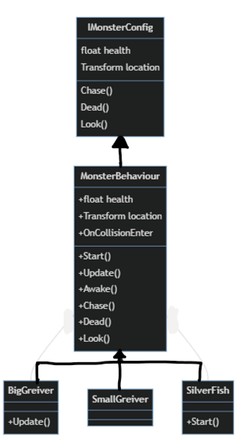i) Polymorphism

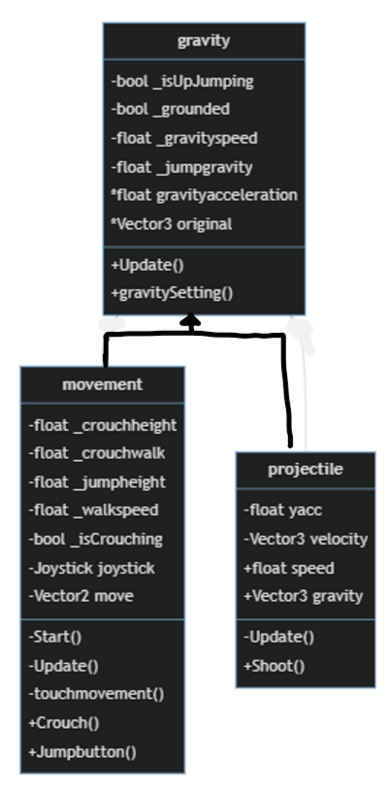

There are sereval monster type in my game. However, they all looks the same except for the speed and alert distance. Inheritance allow me to change some of the code in monsterBehaviour.

This gravity class is the base class for dealing with velocity due to the acceleration of the gravity speed. Both player and weapon needs to be realistic so gravity can provide the y coordinate calculation of gravitational force and projectile motion

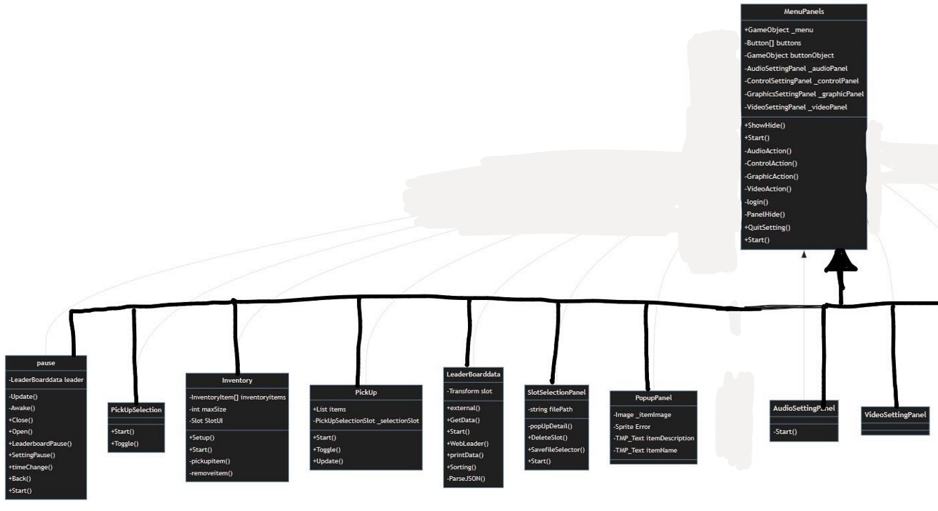 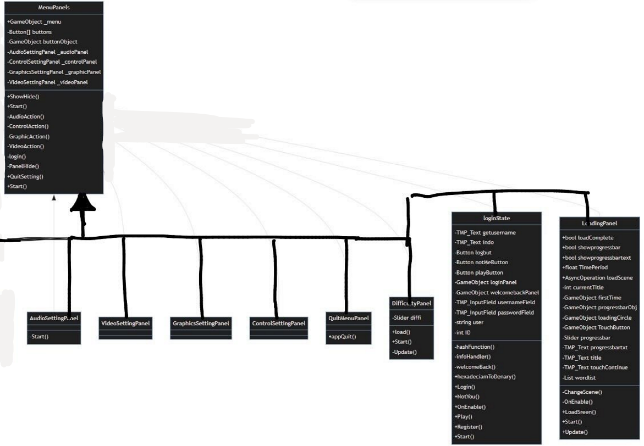



ii) Encapsulation (Aggeration & Composition)

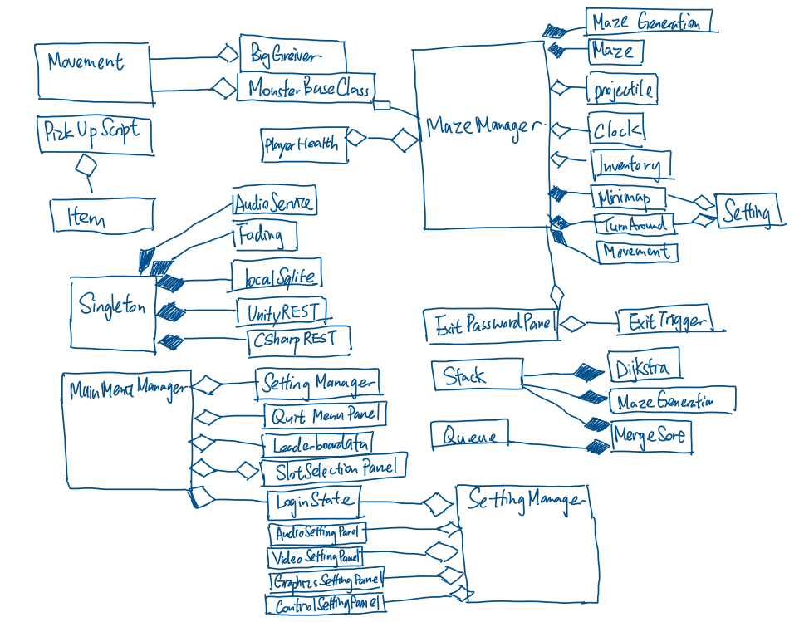

Maze Manager is always enabled and has the most important function to maintain the game working so that maze manager is called by a lot of different class.

## 2.8 Identification of Storage Media

The remote server will be store the data of progress, player info and level details by MariaDB whilst my local database will store the game state and generation of maze, login detail and settings using SQLite.

Reason of choosing local SQLite database because I can minimise the file handling code using SQL declarative programming language. In comparison to online database, it is faster connection and reliable without connecting to the internet.

## 2.9 HCI Rationale

As a realistic 3D mobile game, 3D models is required all around the maze. However, it is not suitable to use low poly model as alternative because it will decrease the realistic of the game. Therefore, It will cost lots of time to creating model all by myself. Luckily, there are lots of unity assets on internet that is free to use. Besides, I want to make the Graphics User Interface of my game looks fancier to attract player so I will use the TMP asset and the User interface template asset. The main colour palette of this game is mostly grey and blue. It represents the maze and the sky as the hope of freedom respectively.

As the game is design in mobile platform, touch friendly is required for the low precision of finger touching. The size of button and font size of text input field could be enlarge and change into a square shape. The colour of button should be bright as most of the texture in the maze and the sky are dark which is hard to see if the button is dark in colour too.

## 2.10 HCI Sample of Planned Input Design

Soundeffect multiplayer NPC appearance object hosse, farming, introduction //storyboard //drawing of the sample game scene

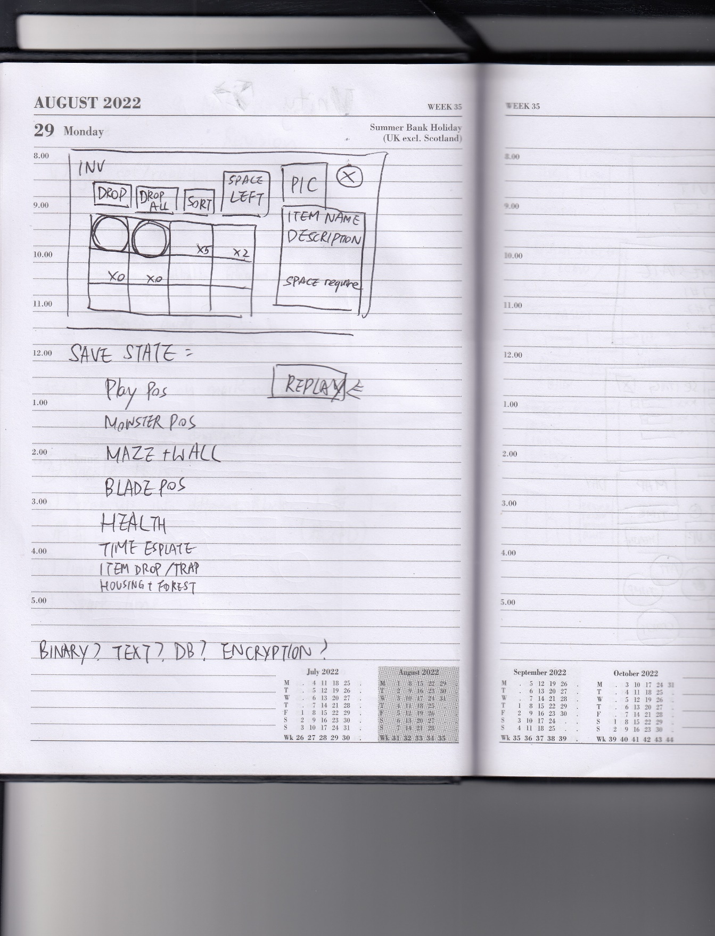 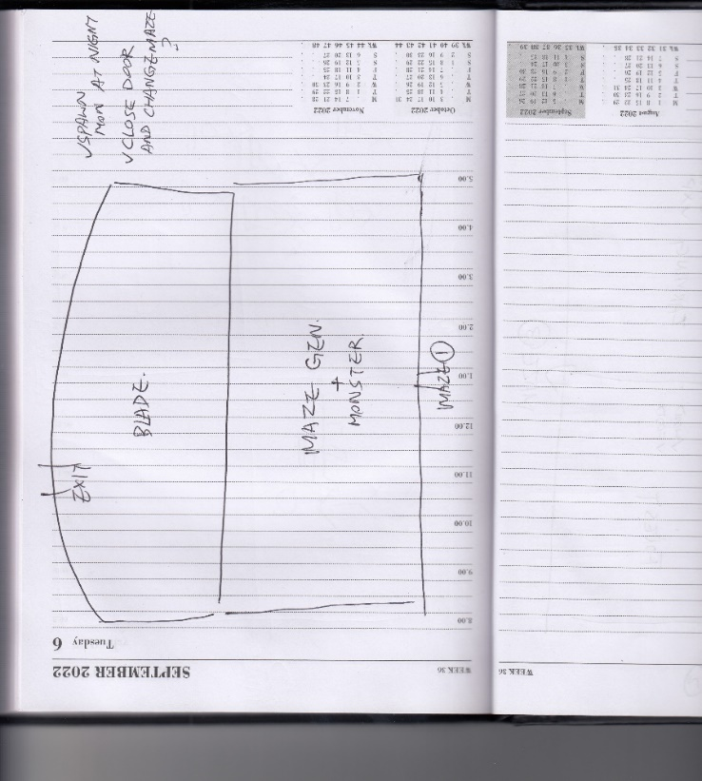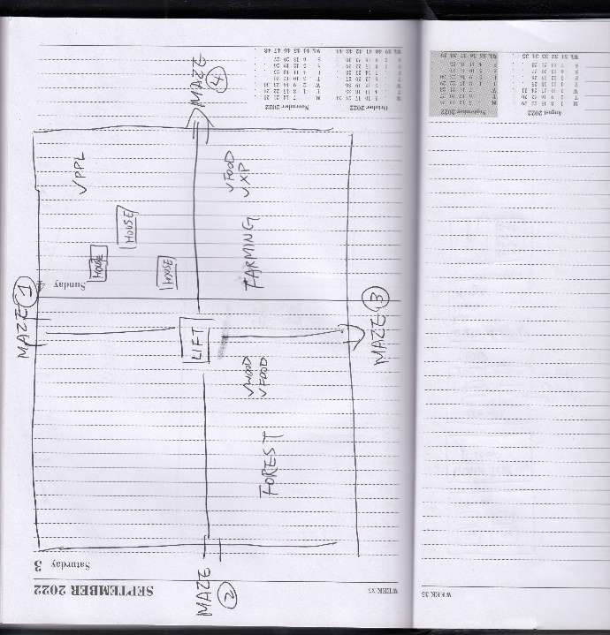 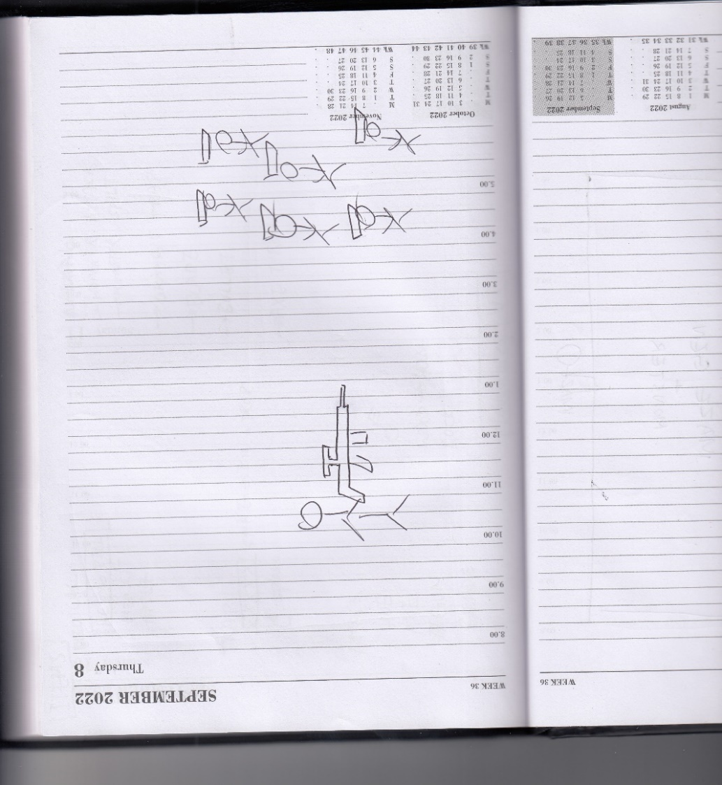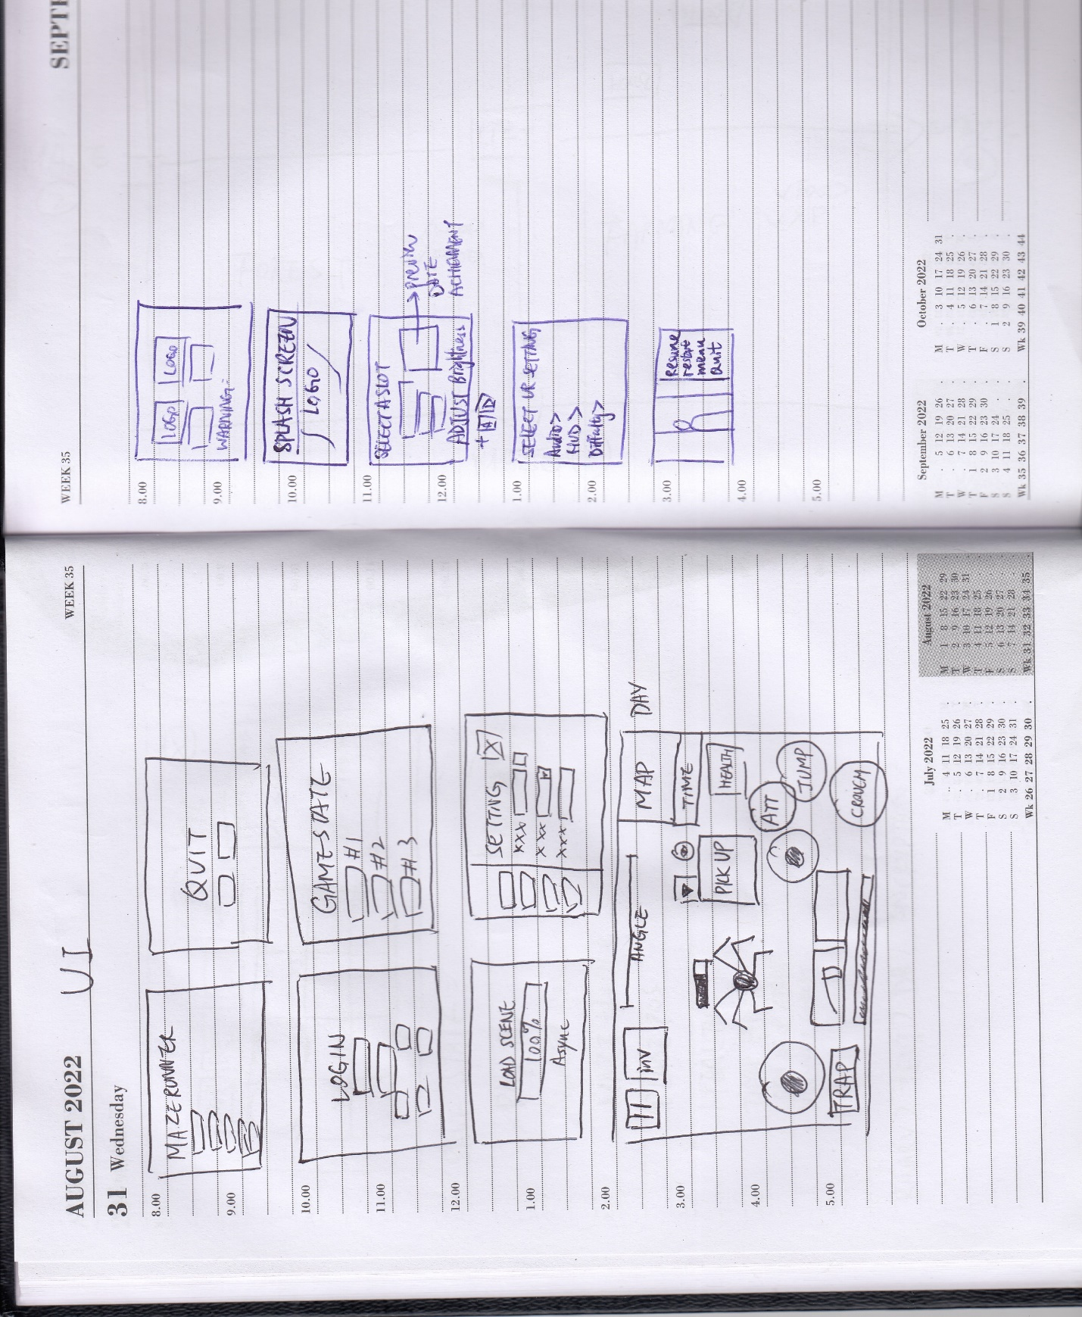 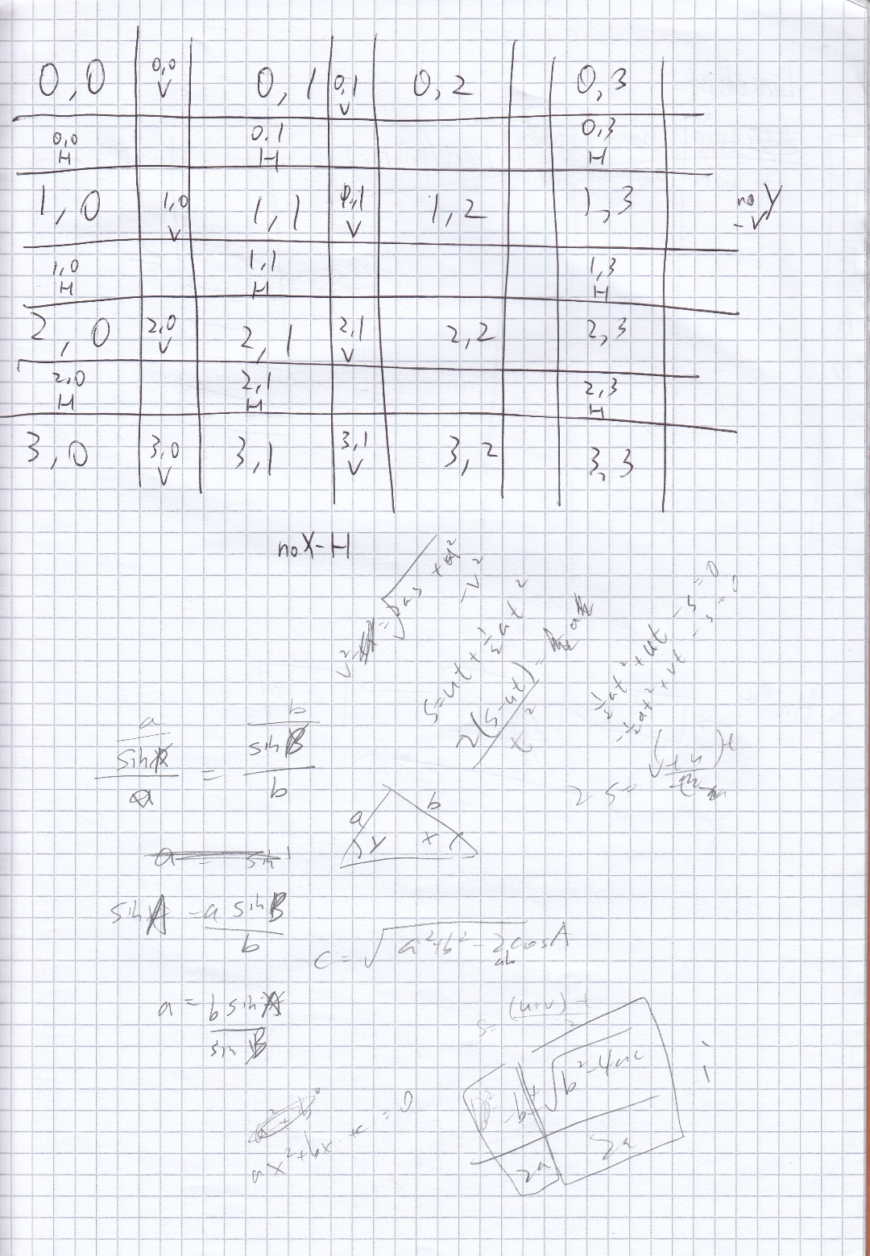

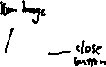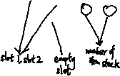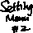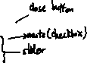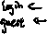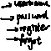

The overview of the maze

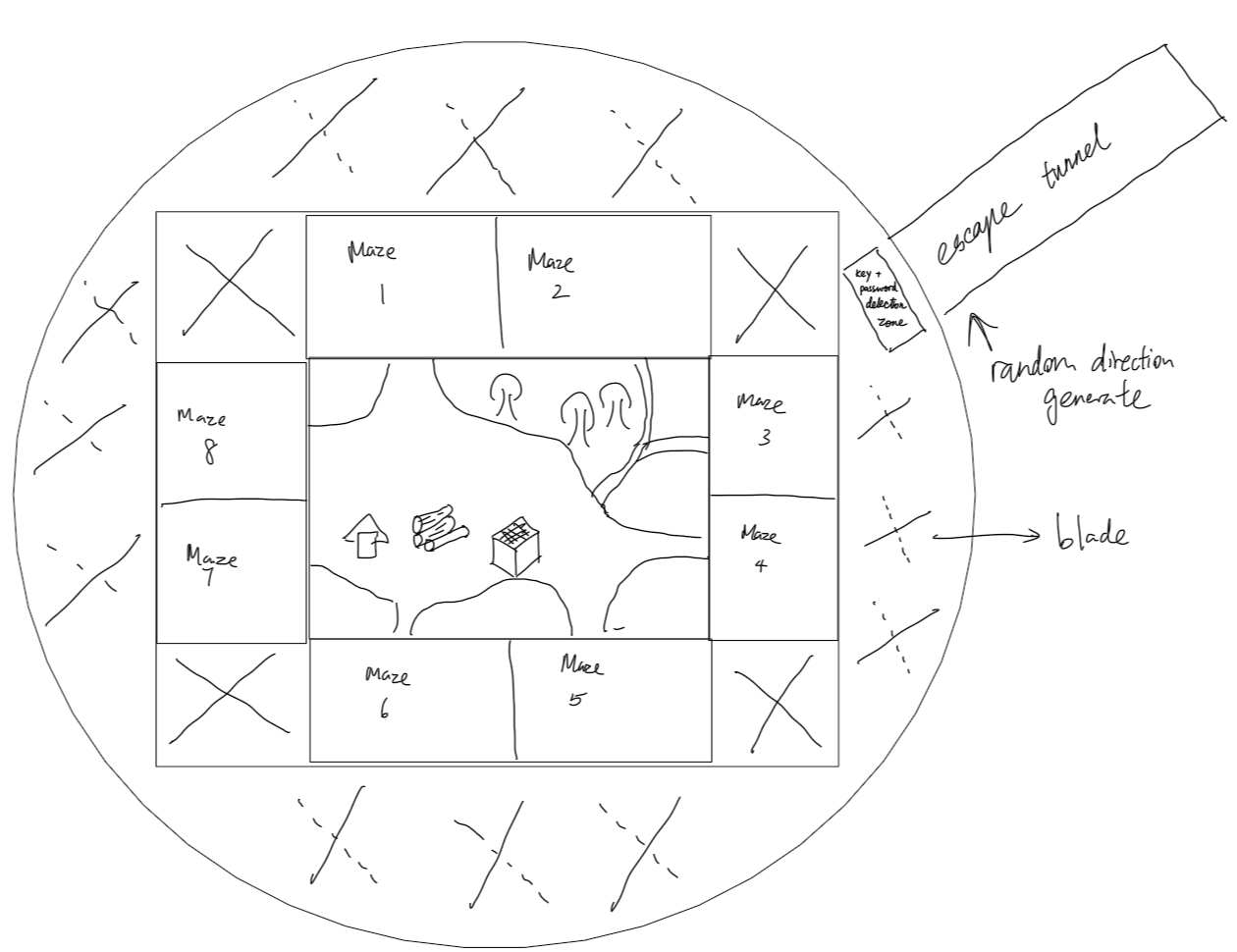

The Storyboard

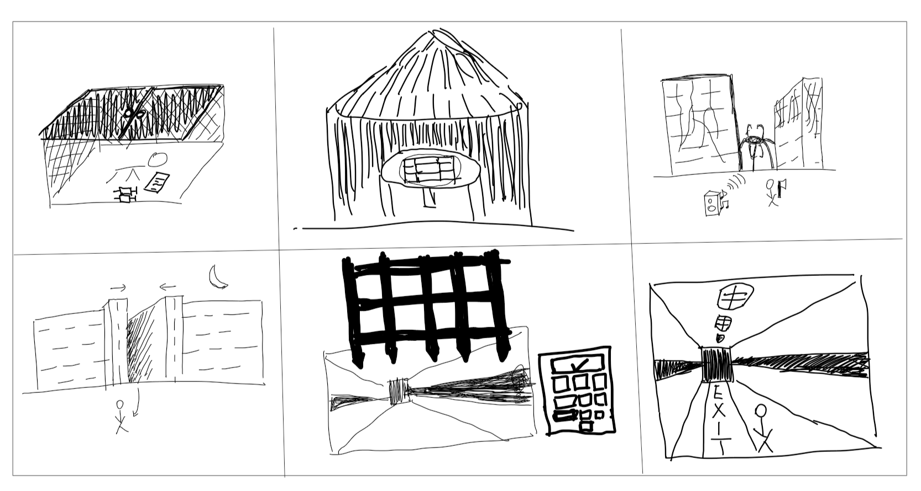

|  |  |  |
| --- | --- | --- |
| The player is sent from the laboratory to the maze by a gauze lift to the maze game | the player explore the safe zone in the maze and reveal the map overview of the maze drawn by previous people | The player should explore the maze and the Greiver will attract to the sound trap for a while so player can use premade weapon to attack the griever |
| At night-time, the maze gate will closed itself and player must come out of the maze to ensure safety. If player is in between the gate closing, he would suffocate to death | the exit gate will be open if the password has been entered correctly | The exit tunnel will be the end of the game |

## 2.11 HCI planed output design

The player will go through the maze and pass the level once go through the exit tunnel

## 2.12 Hardware and Software requirement

A powerful phone which able to run 3D and complex graphics is required as the map of my game is quite large and include a lot of texture. It is essential to have a decent smartphone in order to run this game smoothly. The file size of the game is also quite large due to the texture. Also, register and leader board is out of the game so a browser and network connection is needed

## 2.13 Description of measures planned for security and integrity of data

### 2.13a Security of the data

All the data in the database will be backup into my home server using Rsync protocol. It is based on SSH to provide a encrypted tunnel to backup file to prevent the main database failure. Load balancer has been setup so once the main database is inaccessible, it will automatically redirect to the new database server address.

### 2.13b Integrity of the data

The register website will sanitise the user input and prevent unwanted character. Account will be verified by email One-Time Password to make sure the email address is correct and usable. Password will be stored in a form of hashing and salt data instead of plaintext which can improve the security of user password cracked by hacker

### 2.13c Access Control

A non-admin user is created to access the database with basic privileges including DDL, DML and DQL query only. The password used Upper and lowercase letter, numbers and symbol to form at least 12 digit. The time complexity of cracking the password is O(n!). which is impossible in a lifetime in brute force method.

## 2.14 System security

The server of the server is hosted in a factory in Hong Kong. It is placed in a locked server rack to ensure no one can temper with the physical disk. Although the query is able to access through the internet, both PHP and Node.JS are both backend programming language which normal user has no way to access the code to get the password login, therefore the database is secure from prevent unauthorised access.

Moreover, there is no port forward set in the server. The PHP and Node.JS server scripting only access the LAN to access the data instead of using public IP/ hostname. I have used cloudflare zero trust access platform to setup access right and block out DDoS attack.

There is a risk of being SQL injected by hacker using ‘WHERE user =””’ . To prevent this, all field is sanitised with character checking algorithm and parameterised query is used in PHP and node JS script to prevent SQL injection.

## 2.15 Overall Test Strategy

I am going to use White-box testing for my whole game because the game is developed for mobile platform, which every touch input on the phone is valid. Including the Game Objects that without a listener on touch, the input still count as valid. The test will be based on the objective set in section 1.3 and 1.4 and IPSO table and a narrated testing video will be recorded.

Not only for video testing, but user testing is also a paramount to judge the success criteria of my game. I will ask at least 10 users to test on my game, providing feedback on the game completeness and the improvement could be made.

# 3. Technical Solution

All script is attached into a separate folder which is

|  |  |  |  |
| --- | --- | --- | --- |
| Skills | | | Page |
| >=3 tables interlinked |  | | See 2.4 for E-R diagram | |
| Cross-table SQL |  | | 106 (group by INNER JOIN) | |
| Pivot SQL |  | | 106 (PIVOT) | |
| DDL scripts |  | | 82, 85 (create) 13,24,27-29 (alter) 18,82 (Drop) | |
| SQL scripts |  | | 20,23,24,28-30 (update) 17,22,24,25,27,74,84,104(select) | |
| Hashing | Self-made | | 6-7,75,107 | |
| Lists | built-in | | 20,36,42-43, 48-51,69-70, 76 | |
| Stacks | Self-made | | 12-13, 44, 51-53 | |
| Queues | self-made | | 4-5, 25 | |
| Trees |  | | 10-11 | |
| Recursion |  | | 3,8,10,44 | |
| Dijkstra algorithm | Self-made | | 42-46, 51-52 | |
| Merge sort | Self-made | | 69, 9-10 | |
| Abstract classes, interface |  | | 57,56,64 | |
| Classes (simple OOP) |  | | 2-104 | |
| Inheritance |  | | 12,32-36,65,68,75-78,81,83,87,90,10,56,52 | |
| Server side scripting using request and response objects.(PHP and Node.JS) | |  | 105-108 | |
| Calling parameterised APIs  Parsing SQL Query Result | |  | 74,18  69-71 | |
| SQLite localdb | |  | 101-103 | |
| File handling | | Built-in | 73,84,81,77,17 | |
| Multi-dimensional arrays | |  | 7, 35,42,43,48,51,53 | |
| Binary search | | Self-made | 3 | |
| Text and binary file | |  | 73,78,81 | |

# 4. Testing

## 4.1 Testing method

According to the test strategy I have planned in Section 2.15. I am going to record a video on the game testing. I am going to use the white-box testing as there is no invalid data enter into my system. It is one of the advantage that mobile platform which all input are valid. I am going to use the game objective to test my game as the success criteria of the game. The video will be uploaded onto youtube with timestamp below.

Another testing method would be user testing, I will create a form to ask the player for the feedback and improvement. I will ask for at least 10 player to test my game to make sure the game has been fully tested with different people.

## 4.2 Test Evidence

Test 49, 70, 85 on: <https://youtu.be/bcgBH3yrN0o>

All other test on: <https://youtu.be/gKYPwSDtYlE>

|  |  |  |  |  |  |  |
| --- | --- | --- | --- | --- | --- | --- |
|  | **Objective**  **Section** | **sub** | **Test Description** | **Test Data** | **Expected Outcome** | **Actual Outcome** |
| 1 | 1.3.1 Splash Screen | a)b)c)d) | Start the Game | \ | The game title, maker, warning and continue will show on screen in order | It was as expected |
| 2 |  | e) f) | Click on the loading screen | \ | The main menu will load | It was as expected |
| 3 | 1.3.2 Main Menu | a)b)c)d)f) | The main menu is loaded | \ | A image will fade out, pop up of login reminder will be shown, menu buttons will avaliable to click and login status will be shown | It was as expected |
| 4 |  | e) | Click on continue button before a game has started playing | \ | The button will be disable | It was as expected |
| 5 |  | e) | Click on the continue button after a game session is played | \ | The previous game session will be loaded | It was as expected |
| 6 | 1.3.3 Setting Screen | a) | click on setting button(first time) | \ | The login screen will be pop up | It was as expected |
| 7 |  | b)c)d) | close the login screen/ click on setting after first time | \ | button to switch setting tab will be available and value will load or set to default | It was as expected |
| 8 |  | e) | Click on video option | \ | It will show FOV and minimap size sliders | It was as expected |
| 9 |  | f) | Click on Audio option | \ | It will show 2 sliders to change SFX and Music volume | It was as expected |
| 10 |  | g) | Click on graphics option | \ | It will show brightness and quality sliders | It only has brightness slider |
| 11 |  | h) | Click on control option | \ | It will show 3 sliders to change sensitivity and joystick size | It was as expected |
| 12 |  | i) | change sfx volume and test after setting closed | SFX volume to 0 (mute) | It will mute all effect sound | It was as expected |
| 13 |  | j) | change the setting and restart the game and setting menu | \ | It will load the value as it was before | It was as expected |
| 14 | 1.3.4 Quit Panel | a) | Click on the quit button menu | \ | It will show 2 button which is cancel and quit buttons | It was as expected |
| 15 |  | b) | click on cancel button | \ | it will disable the quit screen | It was as expected |
| 16 |  | c) | click on quit button | \ | it will close the game | it only works on mobile device run as an app |
| 17 | 1.3.5 LeaderBoard | b) | Click on the leaderboard button menu | \ | it will show up an empty leaderboard panel and instruction | It was as expected |
| 18 |  | a)c)d) | Click on the username column | \ | it will update to the lateset data and sort out the username | It was as expected |
| 19 |  | a)c)d) | Click on score column | \ | it will update to on lateset data and sort out score column | It was as expected |
| 20 |  | a)c)d) | click on time column | \ | it will update to on lateset data and sort out time column | It was as expected |
| 21 |  | f) | Click on (A) button | \ | it will show the best player and score and average score | It was as expected |
| 22 |  | e) | Click on [ ] button | \ | it will show the best level score of each player | It was as expected |
| 23 | 1.3.6.1 Login | a) | enter password but leave email field empty | enter password: 12345678 | The prompt will show that the field should not be empty | It was as expected |
| 24 |  | b) | enter less than 8-digit password field | password: 1234567 | An error will show up about the length of password field | It was as expected |
| 25 |  | c) | enter a registered email but wrong password | email: testing2@shalev.ml, password 12345678 | An error will show up mentioning wrong password | It was as expected |
| 26 |  | d) | enter a registered email and correct password | email: testing2@shalev.ml, password Ss12354678 | A prompt will show that user has logged in | It was as expected |
| 27 |  | e) | Close button on the screen | \ | The login menu will be closed | It was as expected |
| 28 |  | f) | Login status on screen after login | \ | The status will show the username of logged in user | It was as expected |
| 29 |  | g) | The login status after restart | \ | The status will remain the same as last login session | It was as expected |
| 30 | 1.3.6.2 Register | a) | enter email and password but leave username field as blank | email: testing@shalev.ml, password Ss12354678 | An error will show all field are not able to empty | It was as expected |
| 31 |  | b) | try enter more than 20 characters in username | enter username: thisisatestingusernamethatmorethan20char | The character after 20 character will be ignored | It was as expected |
| 32 |  | c) | try enter a invalid email address | enter email: hi.com | The email doesn’t match with the regex | It was as expected |
| 33 |  | d) | leave the password field blank | username: testaccount2, email: testing2 | An error will show all field are not able to empty | It was as expected |
| 34 |  | e) | enter less than 8 character in password | enter 123456 in password field | An error will show more than 8 digit password is expected | It was as expected |
| 35 |  | f) | Enter only lowercase and number in password field | end s12345678 in password field | An error will show password mush be include upper and lowercase and number | It was as expected |
| 36 |  | g) | enter common words in password field | enter Ss12345678 in password field | An error will show password is too common | It was as expected |
| 37 | 1.3.6.3 Welcome back | a) b) | click login when logged in | \ | welcome back screen with username will be shown | It was as expected |
| 38 |  | c) | click on play button | \ | it will close the welcome back screen | It was as expected |
| 39 |  | d) | Click on not you button | \ | it will logout account | It was as expected |
| 40 | 1.3.7 Start Game Save Slot Selection Panel | a)c) | click on the red cross button | \ | continue button will be disabled | It was as expected |
| 41 |  | b) | click on yellow detail button | \ | it will show the detail of the slot and slot number | It was as expected |
| 42 |  | d) | click on the computer icon | | it will start the game and save in the slot | It was as expected |
| 43 | 1.3.8 First Time | a)b) | Start a new game | \ | it will start a lift animation and show up difficulty panel afterward | It was as expected |
| 44 |  | c) | Click continue button | | it will open the loading screen and load into character selection screen | It was as expected |
| 45 |  | c) | Choose the highest level | level 12 | it will generate the hardest map and stronger monster | It was as expected |
| 46 | 1.3.9 Character Selection | a) | After the loading screen from difficulty | \ | it will show 4 character card for player to choose from | It was as expected |
| 47 |  | b) | click on the yellow detail box | \ | it will show the detail of the character and a picture | It was as expected |
| 48 |  | c) | click on the YEAP button | Choose Thomas | it will pass back to main menu with a prompt to click continue button | It was as expected |
| 49 | 1.3.10 Maze Generation | a) | click return button in pause menu and continue | \ | the maze will be exactly same | It was as expected |
| 50 |  | b) | click slot1 and slot2 in start game and compare the same maze number | \ | the structure of the maze will be different | It was as expected |
| 51 |  | c) | choose the lowest level in difficulty panel | level 6 | the structure of the maze will be simpler and easy to solve | It was as expected |
| 52 | 1.3.11 Loading Screen | a) | When the loading screen appear | \ | the loading text and the bar will on the panel | It was as expected |
| 53 |  | b) | |  | | --- | | Leave the loading screen more than 15 seconds | | \ | the prompt text will change every 3 seconds | It was as expected |
| 54 | 1.3.12 Main Game | a) | Click on the camera button | \ | the perspective of the player will switch between 1st and 3rd person | It was as expected |
| 55 |  | b) f) | Move the left joystick | \ | the player will move around on the ground and switch between idle and walking animation | It was as expected |
| 56 |  | c)i) | Move the right joystick | \ | the player will turn around and the camera will follow the movement | It was as expected |
| 57 |  | d) | Click on the jump button | \ | the player will jump and cant move when upJumping | It was as expected |
| 58 |  | e) | Click on the crouch button | \ | the player will crouch and move slowly | It was as expected |
| 59 |  | g)h) | When the maze game load | \ | the time, monster kill count will show on top right of screen | It was as expected |
| 60 | 1.3.13 Weapon | a) | click on the axe icon | \ | the attack button will change to the axe icon | It was as expected |
| 61 |  | b) | click on the trap icon | \ | the trap button will change to the trap icon | It was as expected |
| 62 |  | c) | go near to the blade | \ | the blade will injure and deduct the player health | this feature was not in the game |
| 63 |  | d) | click on the attack button with axe icon | \ | An axe will throw forward | It was as expected |
| 64 |  | e) | click on the attack button with trap icon | \ | A trap will be spawn on the ground | It was as expected |
| 65 | 1.3.14 Monster | a) b) | lure the monster to the trap | \ | blood effect will shown and may stop the monster from chasing | It was as expected |
| 66 |  | b) a) | throw an axe to the monster | \ | The monster will play the dead animation and stop chasing player | It was as expected |
| 67 |  | c)d) | walk near to the monster | \ | a warning will shown on top of the screen and monster will start chasing player | It was as expected |
| 68 |  | e)f) | Walk closely to the monster | \ | player health will deduct when touching the monster in short distance | It was as expected |
| 69 |  | g) | wait for 24 hours time in game | \ | A random size monster will spawn near to player | It was as expected |
| 70 |  | h) | Walk near to the monster but separate with a wall | \ | The monster will go through obsolete to chase player | this feature was not avaliable in game |
| 71 |  | i) | kill a monster | \ | the monster will drop a key or loot on the floor when dead | this feature was not avaliable in game |
| 72 |  | j) | deal damage to the monster | \ | A health bar will appear on top of the monster | this feature was not available in game |
| 73 |  | k) | lure the monster in between the gate at sunset | \ | The monster will crush to dead in the gate door | this feature was not avaliable in game |
| 74 |  | l) | walk near to a monster | \ | The monter will pause their attack for few seconds | this feature was not avaliable in game |
| 75 | 1.3.15 Maze | |  | | --- | | a)d) | | When the maze game start | \ | one of the gate will be opened and the next opening gate will shown on the button right of the game | It was as expected |
| 76 |  | b) | wait for 24 hours time in game | \ | the next gate will be opened and the current one will be closed | It was as expected |
| 77 |  | c) | Click on the skip button | \ | the next gate will be opened and the current one will be closed | It was as expected |
| 78 |  | e) | Walking toward to the wall | \ | the wall will stop player moving forward | It was as expected |
| 79 |  | f) | Go through the maze | \ | the player will able to pass through the maze to reach the outer zone | It was as expected |
| 80 | 1.3.16 Exit | a) | Go through the maze | \ | the exit gate will have a 1/4 probability in the outer zone | It was as expected |
| 81 |  | b) | Go near to the exit gate and enter correct password | the opening sequence in the maze | the tunnel will show up and the password entry panel will be disabled | It was as expected |
| 82 |  | c) | go near to the exit gate | \ | the passport entry panel will be show up | It was as expected |
| 83 |  | d) | when the player pass through the tunnel | \ | Passed scene will be load, slot will be deleted and continue button disabled | It was as expected |
| 84 | 1.3.17 Health | a) | click on the heal button | \ | the player health will be increase by 10 | It was as expected |
| 85 |  | b) | When the maze is loaded | \ | the player health will at the maximum value | It was as expected |
| 86 |  | c) | go close to the monster and attack by monster for a short period of time | \ | the player health will be deduct and healthbar start changing effect | It was as expected |
| 87 |  | d) | go close to the monster and attack by monster for a long time | \ | the game over scene will be loaded indicate the player has lost | It was as expected |
| 88 | 1.3.18 Pause Menu | a)b)e) | click on the flag button | \ | A pause panel will be show up, time will be paused and continue button and the quit button will be available to click | It was as expected |
| 89 |  | c)e) | click on the continue button | \ | the pause panel will be closed and the time will be resumed | It was as expected |
| 90 |  | d) | click on the quit button | \ | the main menu will be loaded | It was as expected |
| 91 | 1.3.19 Game Over | a) | when the gameover scene is loaded | \ | the screen will show the level difficulty, score and the time needed and continue button | It was as expected |
| 92 |  | b) | When the continue button is clicked and not logged in | \ | Login panel will be show up | It was as expected |
| 93 |  | c) | When the login panel show up | \ | the close button will be disabled | It was as expected |
| 94 |  | b) | When the continue button is clicked and logged in | | the main menu will be returned | It was as expected |
| 95 | 1.3.6.2 Register | | enter a duplicate username | username: testaccount, email: testing3@shalev.ml | An error will show the field is duplicated | It was as expected |
| 96 |  |  | enter a valid username, password and email | username: testaccount2, email: testing2@shalev.ml, password Ss12354678 | It will redirect to the finish register page | It was as expected |

|  |  |  |  |  |  |  |  |  |  |  |  |
| --- | --- | --- | --- | --- | --- | --- | --- | --- | --- | --- | --- |
| Test No | Time | No | Time | No | Time | No | Time | No | Time | No | Time |
| 1 | 0:22 | 18 | 6:30 | 35 | 2145 | 52 | 1154 | 69 | 3215 | 86 | 3356 |
| 2 | 0:54 | 19 | 6:50 | 36 | 2246 | 53 | 1219 | 70 | ----- | 87 | 16:06 |
| 3 | 1:02 | 20 | 6:52 | 37 | 2757 | 54 | 1252 | 71 | 3418 | 88 | 3929 |
| 4 | 1:50 | 21 | 7:21 | 38 | 2817 | 55 | 1304 | 72 | 3308 | 89 | 3947 |
| 5 | 1200 | 3037 | 22 | 7:48 | 39 | 2833 | 56 | 1322 | 73 | ----- | 90 | 3753 | 4010 |
| 6 | 2:00 | 23 | 2529 | 40 | 4100 | 57 | 1334 | 74 | ----- | 91 | 1638 | 4521 |
| 7 | 2:34 | 24 | 2549 | 41 | 0858 | 4050 | 58 | 1340 | 75 | 3457 | 92 | 1657 |
| 8 | 2:41 | 25 | 2621 | 42 | 0910 | 59 | 14:08 | 76 | 3546 | 93 | 1718 |
| 9 | 3:19 | 26 | 2644 | 43 | 0917 | 60 | 1431 | 77 | 3556 | 94 | 4530 |
| 10 | 3:32 | 27 | 2704 | 44 | 0947 | 61 | 1450 | 78 | 4255 | 95 | 2411 |
| 11 | 3:44 | 28 | 2723 | 45 | 0941 | 62 | ----- | 79 | 3659 | 96 | 2450 |
| 12 | 4:00 | 29 | 2729 | 46 | 1001 | 63 | 1508 | 80 | 3659 | 4323 |  | |
| 13 | 4:28 | 30 | 18:02 | 47 | 1012 | 64 | 3107 | 81 | 4416 | Addition video | |
| 14 | 5:45 | 31 | 1907 | 48 | 1043 | 65 | 3250 | 82 | 4339 | 49 | 0020 |
| 15 | 5:57 | 32 | 2022 | 49 | ----- | 66 | 3418 | 83 | 4513 | 70 | 0228 |
| 16 | ----- | 33 | 2100 | 50 | 2936 | 3833 | 67 | 3338 | 84 | 3527 | 85 | 0221 |
| 17 | 6:07 | 34 | 2226 | 51 | 3000 | 2733 | 3813 | 68 | 3346 | 85 | 3037 |  |  |

## 4.4 User Acceptance testing

12 users has tested my game and the form are attached below

# 5. Feedback and Evaluation

## 5.1 Overall effectiveness

### 1.3.1 Splash Screen

1. The name of the game should be appear before the game starts
2. The name of the producer should appear before the game starts
3. A warning of copyright of the game needed to be shown in the loading screen
4. A Loading Screen should be shown after the names above is shown

As seen in testing, the objective above was completely met. After the player has start the game, the game name, producer and warning screen was shown on the noticeable screen. This could boost the personal branding and the awareness of the game maker. And also the legal notice of the game as this game has used the movie’s idea without notice the film producer. However, the time could be shorten as this is shown on every game start and cost a certain amount of time

1. Loading Screen needs to be clickable after the names shown
2. Main Menu should be loaded after the loading screen is clicked

As seen in testing, the objective above was completely met, Loading screen is shown after the above was shown. This could increase the expectation and the smoothness of loading the main menu screen

### 1.3.2 Main Menu

1. A introduction image should fade out before the Main Menu is shown
2. A pop-up screen should be pop up to alert player to login to save the progress into the Leaderboard
3. There should be 5 buttons on the screen, including Continue, Start Game, Leaderboard, Setting and Quit
4. All 5 buttons listed in 1.3.2c should be able to open different panel when clicked

As seen in testing, objective above was completely met. All UI in the menu including the pop-up, and menu buttons was shown and able to provide the required information player needed. It shows all the feature that this game support within a single screen

1. The continue button should be disable if the game haven’t run before
2. Login state should be on main menu remind the player which account it is logged in

As seen in testing, objective above was completely met. The behaviour of element including the login status and continue button was changed according to the state and logged in and previous saved game save file. This could prevent user enter invalid command to the game and identify the login identity.

### 1.3.3 Setting Screen

1. Login Screen should pop up to make it more convenient to login
2. The Setting Screen should have 5 categories, including Audio, Video, Control, Graphics and Login
3. All 5 categories tabs listed in 1.3.3b will show corresponding setting category

As seen in testing, objective above was completely met. The UI was shown to the user correctly. This multi-tab interface can allow player to locate the corresponding setting categories quickly.

1. Default value should be set before if setting is never open/ configured before

As seen in testing, objective above was completely met. The setting value was set when the user open the setting menu. This could prevent any invalid input setting value input into the save file.

1. Video Option should contains the Field of View of camera and minimap setting
2. Audio Option should contain SFX and Music Volume Setting
3. Graphics Option should contain settings of Quality level and brightness
4. Control Option should contain settings of the size of joystick and Sensitivity of turning around

As seen in testing, objective above was completely met. The UX of the Setting worked as perfect conditions. All setting used slider with extended width for better touch compatibility.

1. Value of settings should be saved in order to retrieve on next game runs

As seen in testing, objective above was partly met. The sound system is not fully depends on my Audio source, as I used external UI element, they have include some audio source which I cant control the . For the setting value saved locally, I should change the SQL query for accurately get and save the data instead using * in query statement with random setting column.

### 1.3.4 Quit Panel

1. The quit panel should show 2 buttons including Quit Button and a Cancel Button
2. The game should be quitted after Quit Button mentioned in 1.3.4a is clicked
3. When cancel button is clicked, quit panel is disabled and return to main menu

As seen in video testing, objective above was partly met. The quit action could not work in the windows environment. However, the user was able to trigger the leave game option by clicking quit button. Overall, user likes this as they could prevent accidently click on back option and exit the game unexpectedly.

### 1.3.5 LeaderBoard

1. A leaderboard panel and 4 selection columns including player username, level, score and time used needs to be available for player click

As seen in testing, objective above was partly met. The UI item has been change into a better scoring method and level selection instead of game mode chose. The user understanded the changes that brings a better gaming experience to them.

1. An instruction will pop up talking about the sorting and statistics players can access
2. Different columns will be sorted using merge sort based on user selection
3. Leaderboard data needs to be automatically updated

As seen in testing, objective above was completely met. The sorting function was working smoothly, the user can lookup on the data according to the data they wanted to compare.

1. When player performance button is clicked, the level score of each player will be shown
2. When all statistic button is clicked, best player of each level and average score will be shown

As seen in testing, objective above was completely met. The detailed statistics from the database is shown on the website. This could convenient for player who wants to compare their score of the game without opening the game.

### 1.3.6 Login & Register

1.3.6.1 Login

1. email field must not be blank
2. password must be longer than 8 characters
3. wrong password prompt will be shown if the password or username entered doesn’t match with the detail in database
4. A login successful prompt will be shown if both password and username entered correctly and match with the data in database
5. When the close button is clicked, the login screen will be disable
6. Login state will be automatically update in the main menu screen
7. The login state will be saved in local file and automatically login in when game restarted

As seen in testing, objective above was completely met. The login field was checked with input criteria and login status was updated when logged in. The login input from the player will check with the database which takes some time. There should be some prompt on “loading, please wait”.

1.3.6.2 Register

1. Username field must not be blank
2. Username field must not be more than 20 characters
3. Email field must include an @ symbol and follow correct email regex
4. The password field must not be blank
5. The password field must be more than 8 characters
6. The password field must contains one uppercase, one lowercase and one number
7. The password field must not be contains common character such as “1234” and “pass”

As seen in testing, objective above was completely met. Invalid user input has been filtered out and limited has prevented to maintain the integrity of the database.

1.3.6.3 Welcome back

1. If the game is logged in, the welcome back screen will replaced the login screen
2. The username logged in will be shown on the screen.
3. The play button and the close button will be confirming the login detail is corrected.
4. The login state will be cleared and return to the login screen if the not you button is clicked

As seen in testing, objective above was completely met. The game automatically show up to welcome screen instead of login screen to prevent duplicate input and verify for the username. Log out button is replaced with not you button as the game was design one account per player.

### 1.3.7 Start Game Save Slot Selection Panel

1. Data of the slot will be deleted and the continue button will be disable in the main menu
2. Pop up will show the detail of last play and the current score and time used to spend on the game and index of the slot

As seen in testing, objective above was partly met. The pop up which shows the last played time and the slot number was shown to the player. However, to improve the game experience and smoothness, current score and time used has not shown as it may slow down the process on simply showing the pop up.

1. Game Save Status can be delete through a cross button and the continue button will be disable if deleted successfully
2. Game will start when either slot is clicked , loading screen will appear

As seen in testing, objective above was completely met. The game has started when the slot has been chosen and store the game status into the slot. The player is able to reopen the game session clicking on the same slot. Continue button and the game state was deleted when the tester click on the red cross button indicate delete option.

### 1.3.8 First Time

1. Lift animation should played after the screen is loaded
2. Difficulty panel should appear after the animation ended
3. There should be 6 level in the difficulty selection

As seen in testing, objective above was completely met. The lift animation was run smoothly and it match with the opening of the movie maze runner which increase substitution of the player into the game.

### 1.3.9 Character Selection

1. Player can choose from the 4 different characters
2. Detail of player will shown when the pop up button is clicked
3. Main menu will be returned after the player has confirmed their character selection

As seen in video testing, objective above was completely met. There was 4 different selection of characters and all with different model and abilities. However, in the user testing section some tester report that the game has crashed after the selection of character. The issue had been fixed after I changed few lines of code.

### 1.3.10 Maze Generation

1. The maze should generate and saved before the game start
2. The maze will generate randomly in every new game
3. The maze will be more complex if the level increase

As seen in testing, objective above was completely met. The maze increased its difficulty based on the level of the game and it automatically generated every game. The user love this feature as it provide the freshness of playing this game.

### 1.3.11 Loading Screen

1. Loading bar and text will indicate the progress of scene loading
2. Loading text will be change every 3 second to entertain players

As seen in testing, objective above was completely met. The loading screen was include with a indicator and a word prompt to simulate the loading of maze in the movie. I get this idea from the game Jetpack joyride and it increase the substitution of the player and it is fun to read some non-sense loading text. However, It could be improved by automatically disable the loading screen when the scene is completely load.

### 1.3.12 Main Game

1. Player is able to switch between the 1st and 3rd person camera

As seen in testing, objective above was completely met. The player was able to switch the camera perspective. Most tester prefer I put the first person perspective as default because the animation is lack from this game and it looks more natural in movement while in 3rd person perspective.

1. Left joystick needed to be able to control the movement of character
2. Right joystick should be able to control the direction of movement
3. Jump action will be performed and movement will disable when the jump button is clicked

As seen in testing, objective above was completely met. The movement and direction of the player worked in the game. Some user doesn’t like the controller input as the control in mobile game as they cant change to the exact position instantly. Instead, a point-to-point control could be replaced to improve the experience of controlling the character.

1. Crouch action will be performed and movement will be slow down when the crouch button is clicked

As seen in testing, objective above was completely met. It did walk slowly and the body become shorter when crouching. However, some tester reported that the character is stuck into the floor while crouch. It was a known bug as the character doesn’t have a crouch posture available. If I have more time to improve, I would make a smooth transition and a crouch posture for the character.

1. The animation of the player will loop between walking and idle

As seen in testing, objective above was completely met, the character is looping between walking and idleing. However, this isn’t ideal as the character should change the posture corresponding to the movement of the player in order to make the character looks realistic.

1. The time of the game will be shown on the screen
2. The kill count of monster is shown on the screen

As seen in testing, objective above was completely met. The UI of the main game contains the essential information for player to pass the level and the current score of the game. Some of the tester was confused with the number of the sequence as it was randomly generated. But overall, it is clear to see by the player.

1. The camera will automatically follows the player

### 1.3.13 Weapon

1. The attack icon will change to the current weapon selection
2. When one of the weapon slot is clicked, current weapon will change to the clicked weapon

As seen in testing, objective above was completely met. The weapon was changed when the player selected the weapon slot and able to utilise it when attack button pushed. However, the inventory system was not implemented so the weapon was fixed into 2 types only.

1. When the player collide with the moving blade, it will deduct player health

The objective above wasn’t met as the blade wasn’t added to the game. It had bugs like player stuck inside the blade which may provide a bad game experience so I decided not to add this until the difficulty is reduced.

1. The axe will throw forward when axe selection button and attack button is clicked
2. Trap will be placed when current weapon is set to trap and attack button is clicked

As seen in testing, objective above was completely met. This trap and the axe was throw/ use as expect and the tester was satisfied with the way weapon is used and they hope there was some more challenging method of dealing monster. As all weapon deal in long distance without getting hurt by the monster but no option to deal with short distance.

### 1.3.14 Monster

1. The health of the monster will be deducted when the axe or trap collided
2. The monster will be dead when the health is below 0 and not dealing any damage to player

As seen in testing, objective above was completely met. The blood effect of the monster was shown when it get hurts and dead when enough amount of damage is deal. However, some tester suggest the monster should de-spawn if they were dead.

1. When the monster spotted and moving toward the player, a warning banner will pop up
2. The monster will only chase player within certain distance
3. The monster will start attacking player within a small distance
4. When the monster is attacking player the player health will be decrease

As seen in testing, objective above was completely met. The monster will chase the player with notification to player and health deduct when player was attacked by the monster in short distance.

1. Random type of monster will be spawn every day

As seen in testing, objective above was completely met. Different size of monster was spawn with different speed and chase distances.

1. Monster should use shortest path algorithm to chase player
2. The monster should drop a key or other loot when they are dead
3. The monster health is shown on the top of the monster
4. The monster will be crushed to dead if it doesn’t have enough time to pass through the gate of the maze

The objective above wasn’t met as inventory system and dijkstra system wasn’t implemented into the game yet. This could improve the game experience however it wasn’t essential for the gameplay.

1. Monster attack will be cooled down before the next attack

As seen in testing, objective above wasn’t met. The monster deal too much health to the player in short period of time. Some tester commented this feature can maintain a balance in combat system of the game.

### 1.3.15 Maze

1. One of the gate will be after the game started
2. The next opening gate will be changed every 24 hours
3. When the skip button is clicked, the next opening sequence will be opened
4. The maze opening sequence will be shown on the screen

As seen in testing, objective above was completely met. The maze was opened in sequence and could be skip by the button. However, tester who never watch the movie was confusing the opening sequence of the maze and thought the skip button was broken. I should added some tutorial on explaining how the maze opening mechanic works.

1. The player should not be able to pass through any wall and maze in this game
2. The maze should contain a walkable path to reach the exit side

As seen in testing, objective above was completely met. The maze was able to pass to the exit side without go through the wall. However, some tester has found a invisible wall as the collider has moved due to the animation which affect the passing of the maze.

### 1.3.16 Exit

1. The exit is located in one of the maze zone only
2. The exit gate should be open when the player typed in password correctly

As seen in testing, objective above was completely met. The exit gate was only located at one of the 4 maze exit zone. The player had to put in the maze opening sequence to open the maze gate when the password screen is pop out.

1. Player should hold the key in order to make the password screen visible

The objective above was not met. As the monster loot and the inventory system has not implemented in my game. Instead, when the player walk near to the gate, the password field was shown up.

1. The progress of the game will be deleted as the level is finished

As seen in testing, objective above was completely met. The continue button was disabled and a new session will be started if the same slot is chosen.

### 1.3.17 Health

1. Health will be +10 when the heal button is clicked
2. At the start of the game, the health is at the maximum value
3. Animation will be played when the health value is changing
4. Gameover screen will show up when the player health is less than 0

As seen in testing, objective above was completely met. The health will change correspond to the heal button and the monster attack. While the health had been changed, the animation of chip away will shown in the healthbar to indicate the health that player is deal. It was effective for player to notify the change of health.

### 1.3.18 Pause Menu

1. The menu will show up when the button is clicked
2. There are 2 buttons in pause menu, return and quit the game
3. The pause menu will close when the return button is clicked
4. When quit button is clicked, it returned to the main menu and progress will be saved in local file
5. The time counter of main game should be paused

As seen in video testing, objective above was completely met. The pause menu UI worked in perfect condition and the time in game has been paused while player is in the pause menu. There is a probability that player will abuse the pause menu however as it is not a multiplayer game, it should let player to save their progress whenever they don’t want to play.

### 1.3.19 Game Over

1. The screen will contain following elements, whether the player passed, the time used by the player, the difficulty level and the monster player killed and continue button.
2. Login screen may appear if the player haven’t login yet
3. The close button of login screen is disable to forced player to login and save the score

As seen in video testing, objective above was completely met. After the game was finished, the game over screen was automatically shown up and providing game statistics with leaderboard upload if player is logged in. However, in the user testing section. The comment wasn’t too good. Some tester report that the game over screen cant skip the login screen in the game over screen. It was intentional as I hope player would login and upload to the leaderboard system to keep track of their work

## 5.2 User Feedback

### 5.2.1 Positive comment I have got

“The maze is easy to navigate”

“Simple to understand and joystick easy to use”

“The map wasn’t very hard to navigate with difficulty level of 6”

“Pretty cool game especially if you like the game Maze Runner”

“The game is quite straight-forward”

“This game is excellent”

“I liked the mini-map”

“Easy to navigate the maze”

“Randomised gate opening was very good”

“The graphics and animation is cool”

### 5.2.2 The negative comment that needs to improve are

“Did see through the wall and lagged a bit in the forest zone”

“The XBOX controller is not match with human design”.

“No introduction to explain how the game works”

“The password of the gate is difficult to remember”

## 5.3 Improvement and extension

If I were continuing to develop this game, I would add a tutorial to explain the control and mechanics of the main game and it should be designed to guide players through the first level step by step. Additionally, a compass should be included to prevent players from going in the wrong direction. To further enhance the gameplay, a quest system should be implemented to award players with money and power-ups. A coins and vending machine system could also be added to spend the award player has earn.

Considering potential issue on internet connection, the game should include an option to skip the online login. Additional feature to consider is the stamina bar, which would allow players to sprint for a period of time, an inventory and pickup system would also be beneficial for variety of gameplay, multiplayer sessions and path finding of monsters for better interaction and better visibility in mini-map.

Testers have suggested adding better 3D models and animations for each player's walking and attacking movements to make the game more realistic. Optimising the texture of the maze could help make the whole game more attractive and better performance. It is suggested that animation of gate opening from the movie should be added as well. The interaction of NPCs are another important aspect to consider. Additionally, maze runner features like housing and farming zones could be included. The improvement above could make the game match closely to the original movie.

To prevent overcrowding of monsters, some of them should de-spawn when inactive or after they die. Some tester suggested that the difficulty of fighting monsters should be increased. To achieve this, attack speed could be slowed down while their damage output to players should be increased. Furthermore, a crosshair should be included for better aiming in game, and more weapons should be added to the game including a short knife for close-range attack.

One tester suggested a different approach for the game, where instead of providing a wide map with different mazes, the game could consist of one maze per level, with the exit always on the opposite side to make every move of the player worthwhile. This could potentially provide more levels staged based on only one map.